

**AMERICAN INTERNATIONAL**

**UNIVERSITY-BANGLADESH**

**Assignment Cover Page**

|  |  |  |  |  |
| --- | --- | --- | --- | --- |
| Assignment Title: | Website testing with Selenium | | | |
| Assignment No : | 01 | | Date of Submission: | 17 July 2022 |
| Course Title: | **SOFTWARE QUALITY AND TESTING** | | | |
| Course Code: | CSC4271 | | Section: | E |
| Semester: | **Summer** | 2021-22 | Course Teacher: | **ABHIJIT BHOWMIK** |

**GROUP INFORMATION:**

|  |  |  |  |  |
| --- | --- | --- | --- | --- |
| **Serial no** | **Name** | **ID** | **Program** | **Signature** |
| 1 | **MEHEDI HASAN EMON** |  | BSc [CSE] | Emon |
| 2 | **TANJIM MAHMUD RAKIN** |  | BSc [CSE] | Rakin |
| 3 | **KAZI AHSANUL HAQUE SHOJIB** |  | BSc [CSE] | Shojib |
| 4 | **RIFAT AHMED** |  | BSc [CSE] | Rifat |

|  |  |  |
| --- | --- | --- |
| ***Faculty use only*** | | |
| FACULTYCOMMENTS | **Marks Obtained** |  |
|  |
|  |
|  | **Total Marks** |  |
|  |
|  |

**STEP:1**

**JAVA JDK AND JRE DOWNLOADING, SETUP PROCESS AND VARIABLE SETUP:**

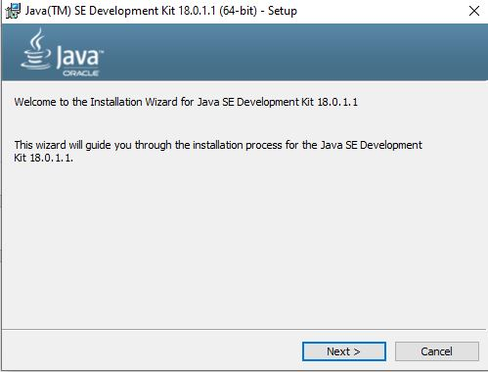

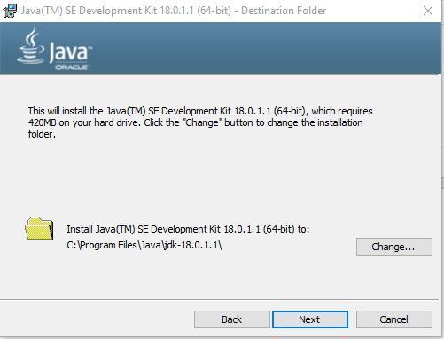

**JAVA VERSION CHECK:**

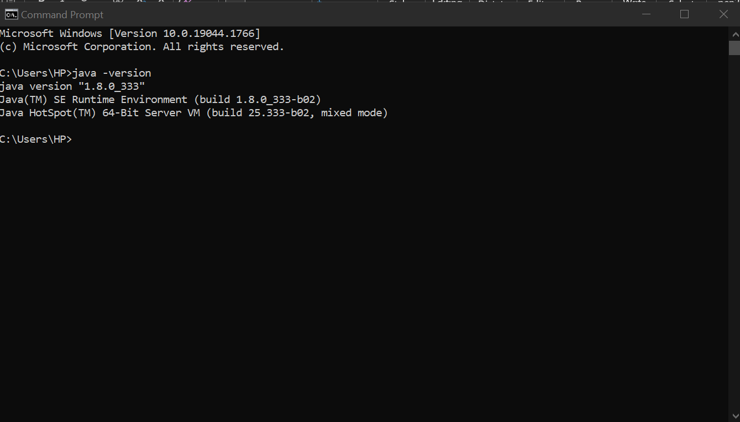

JAVA ENVIRONMENT SET UP

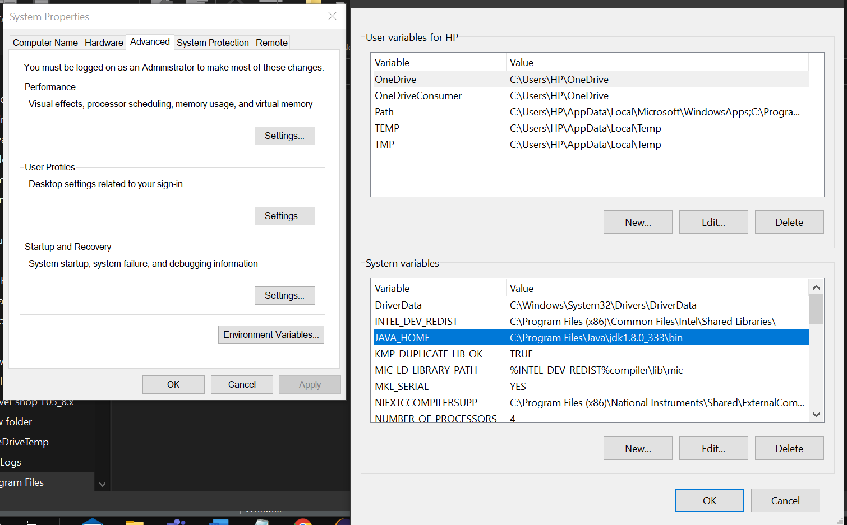

**STEP:2**

ECLIPSE IDE SET UP AND PROJECT CREATE:

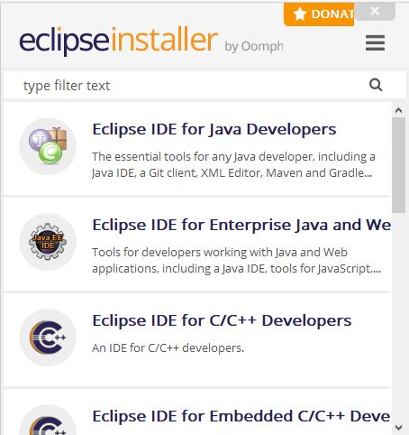

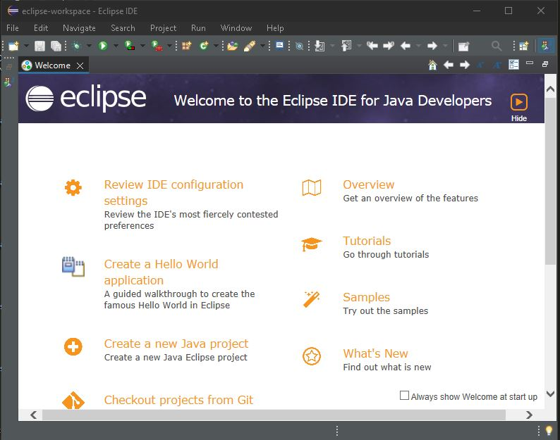

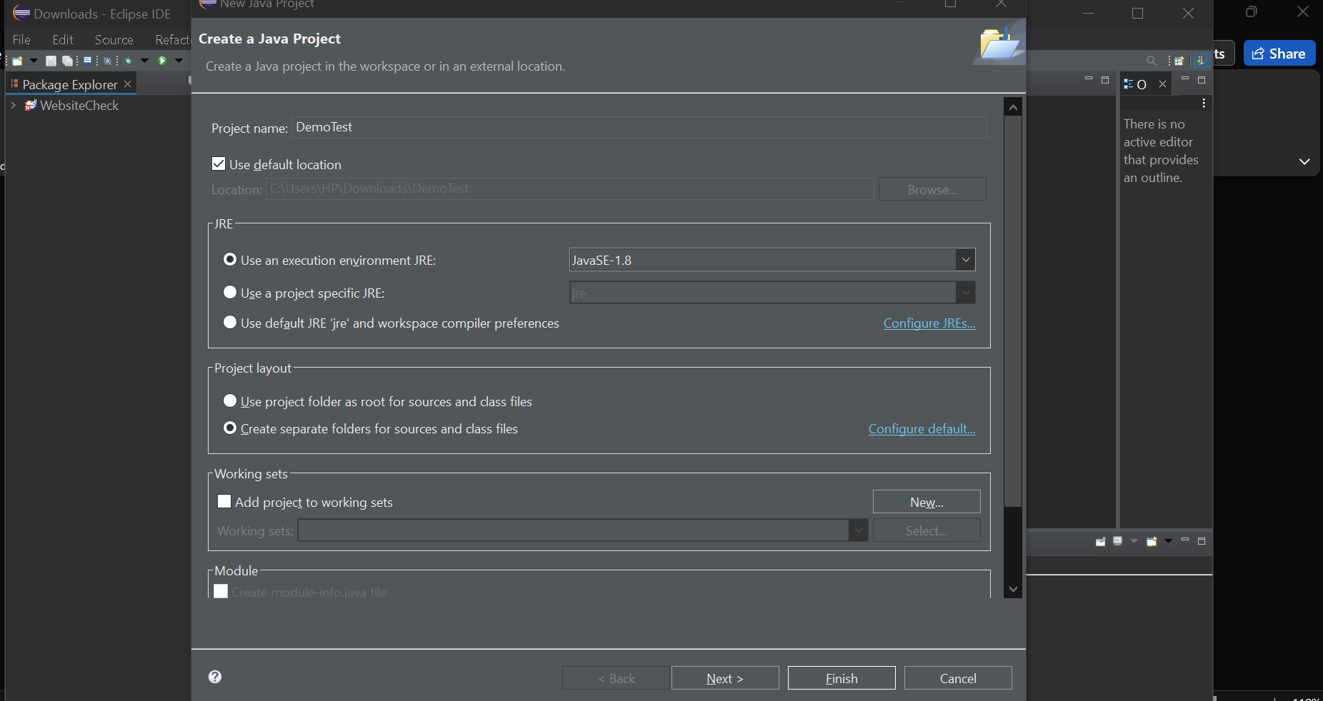

CREATE AN JAVA PROJECT

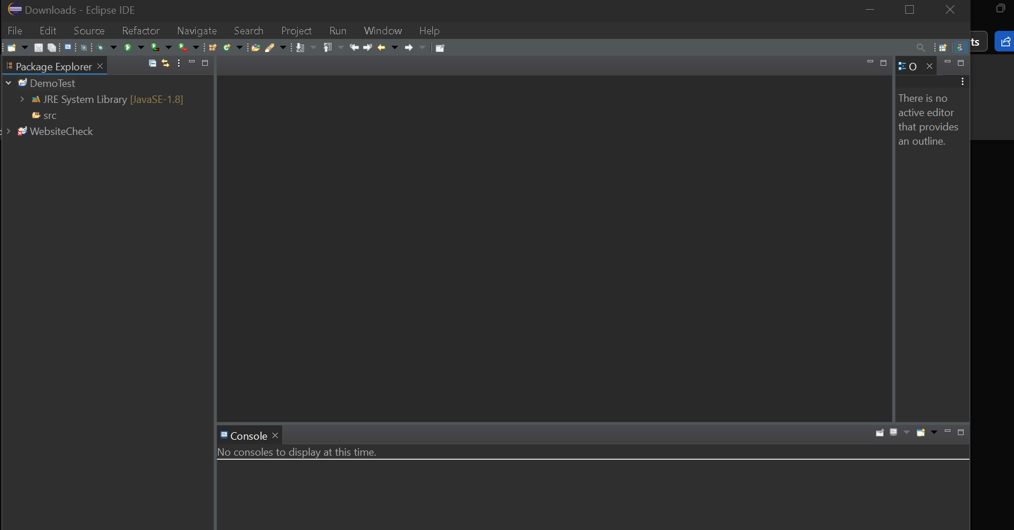



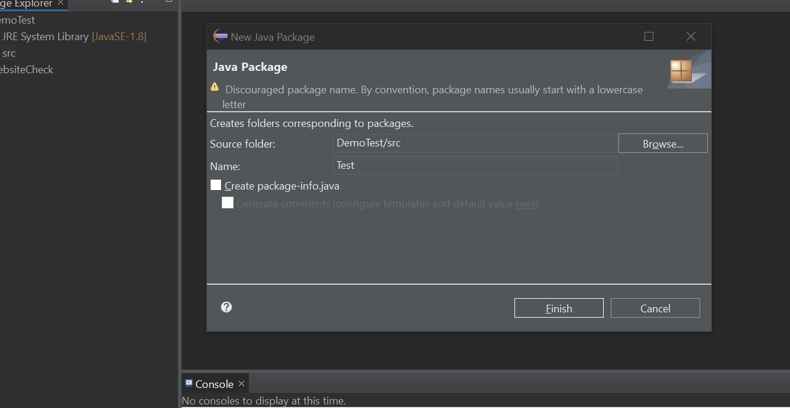



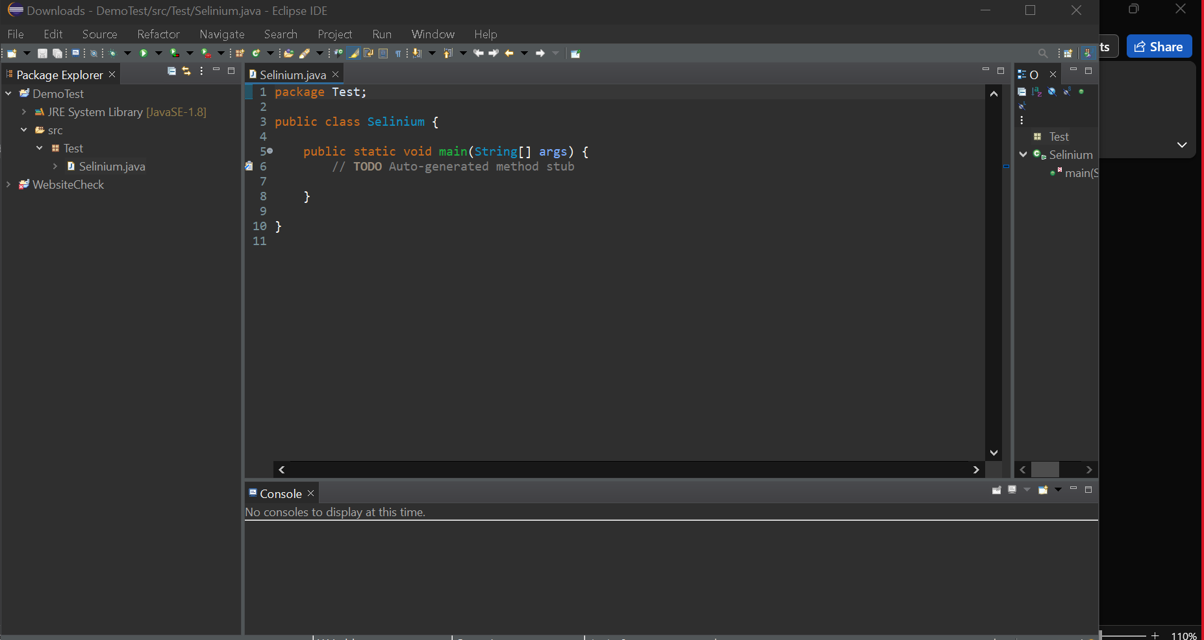



**STEP:3**



**SELENIUM IDE AND CHROME DRIVER INSTALLATION**



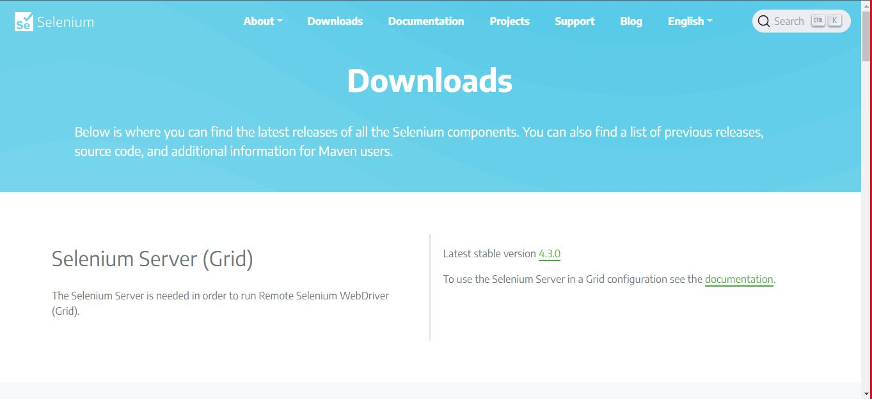



**Added downloaded selenium.jar file into Eclipse IDE**



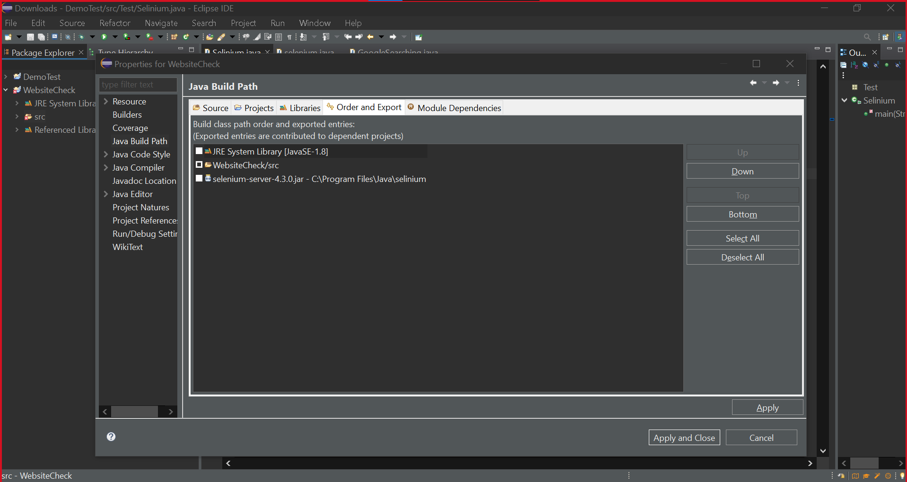

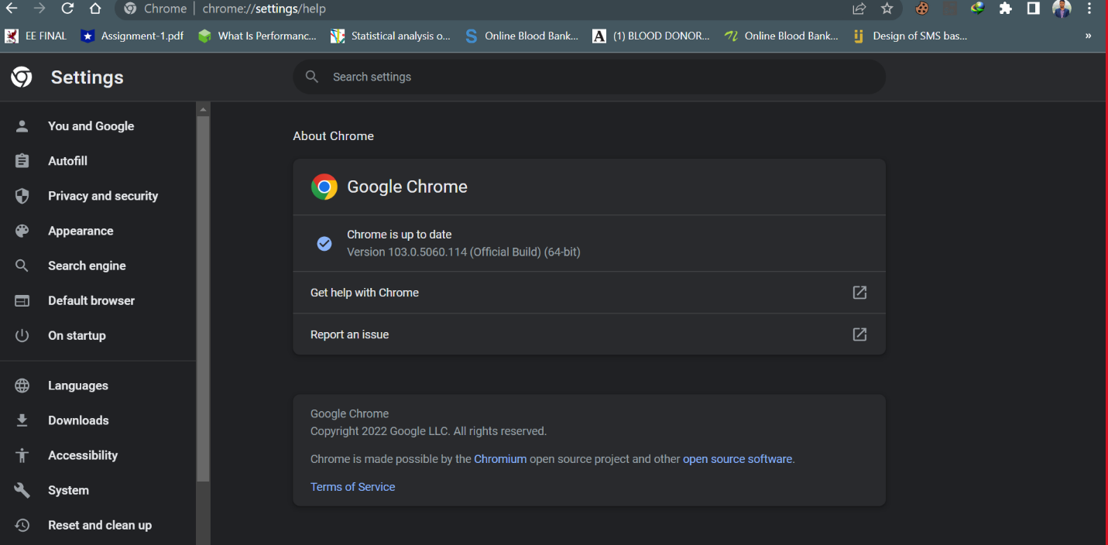

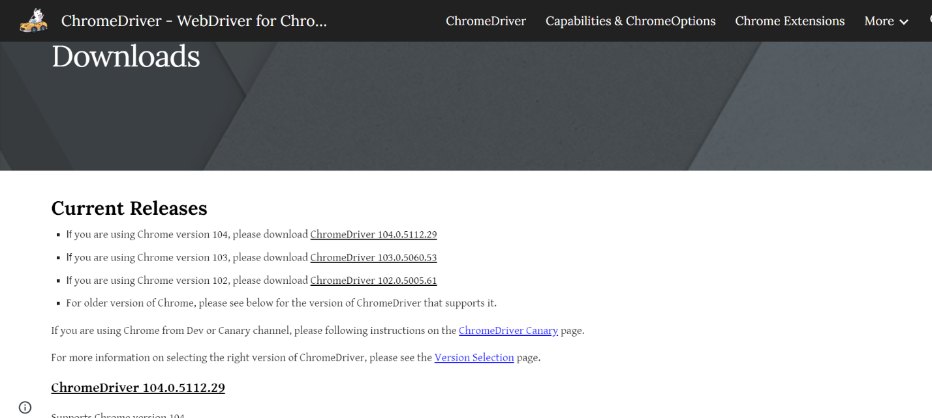

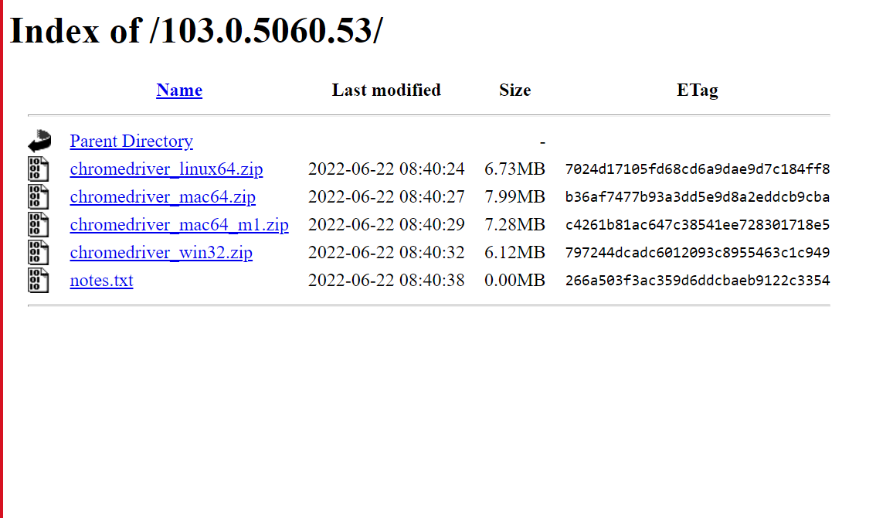

**FOLDER SET UP:**

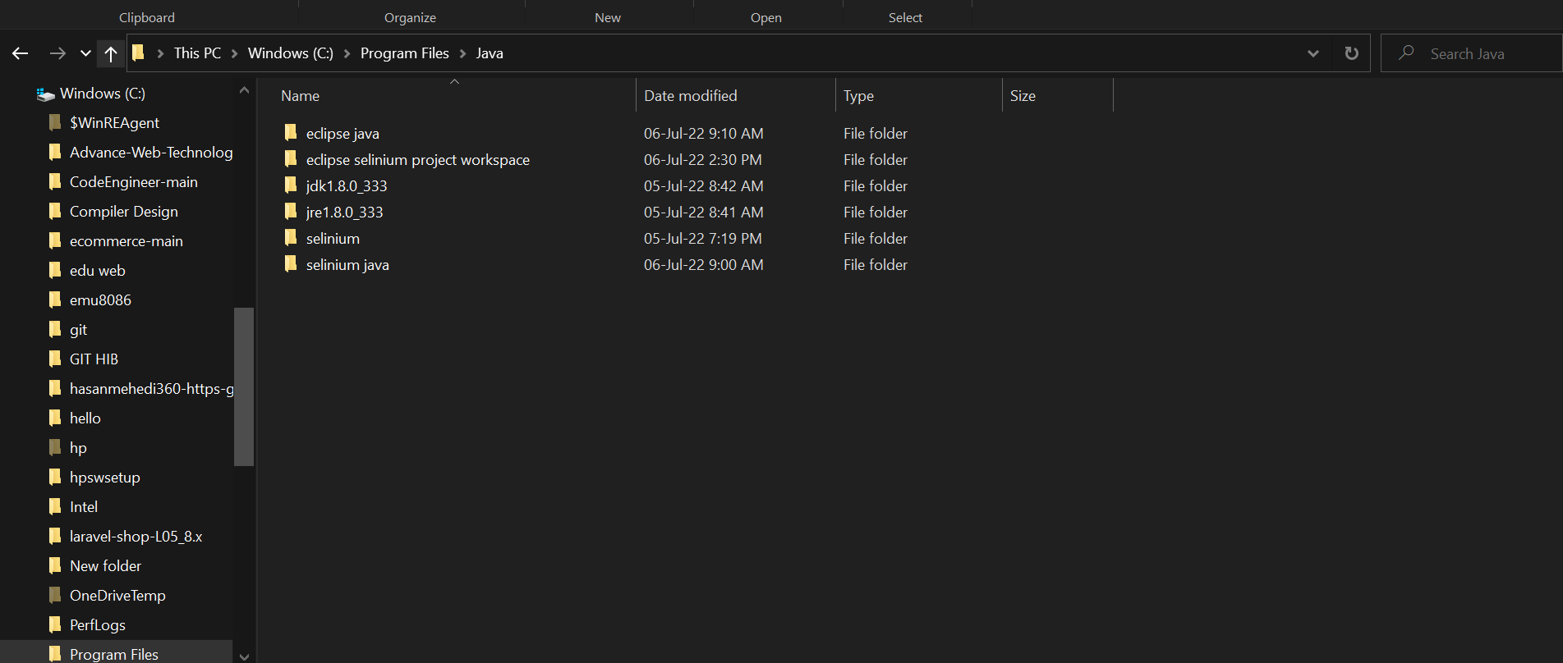

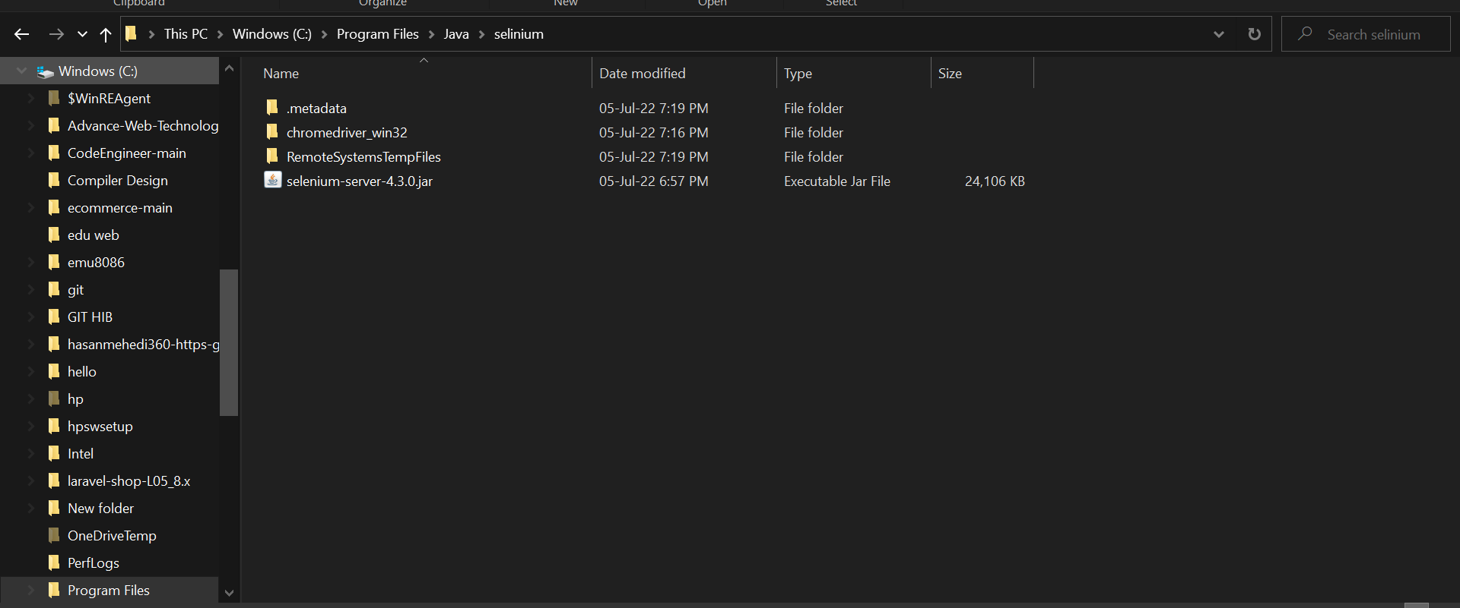

**TESTING WITH ECLIPSE IDE & SELINIUM**

**LINKEDIN LOG IN CHECK**

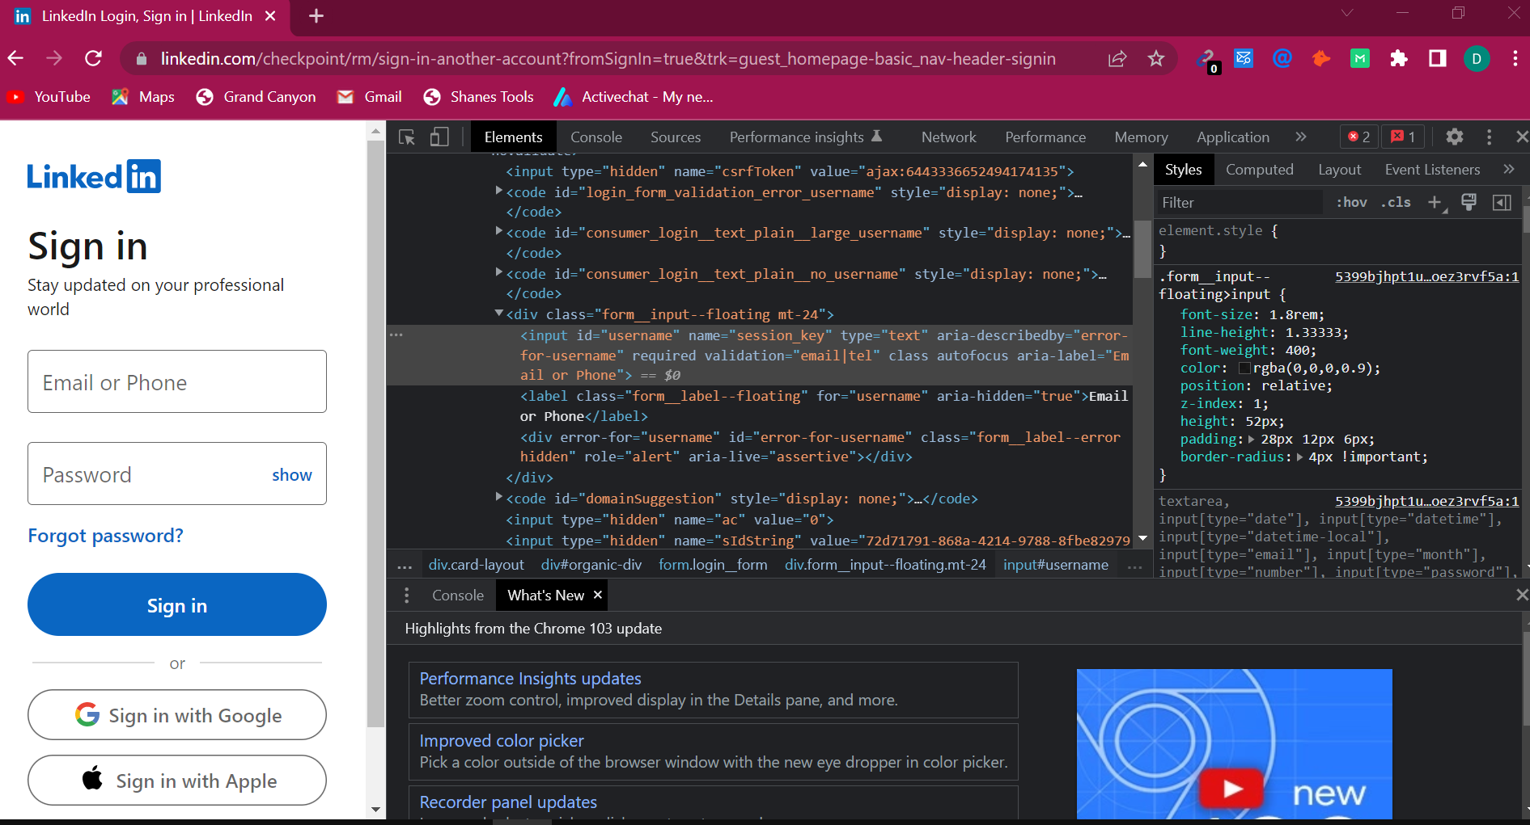

When user credential are okay

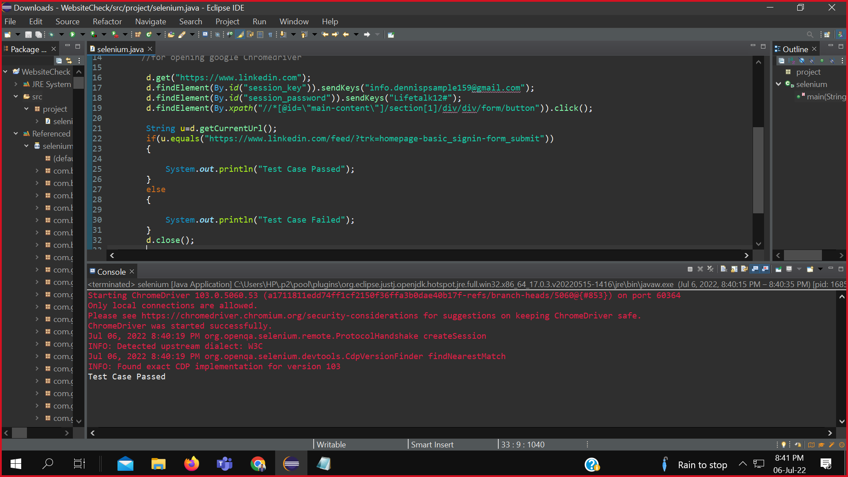

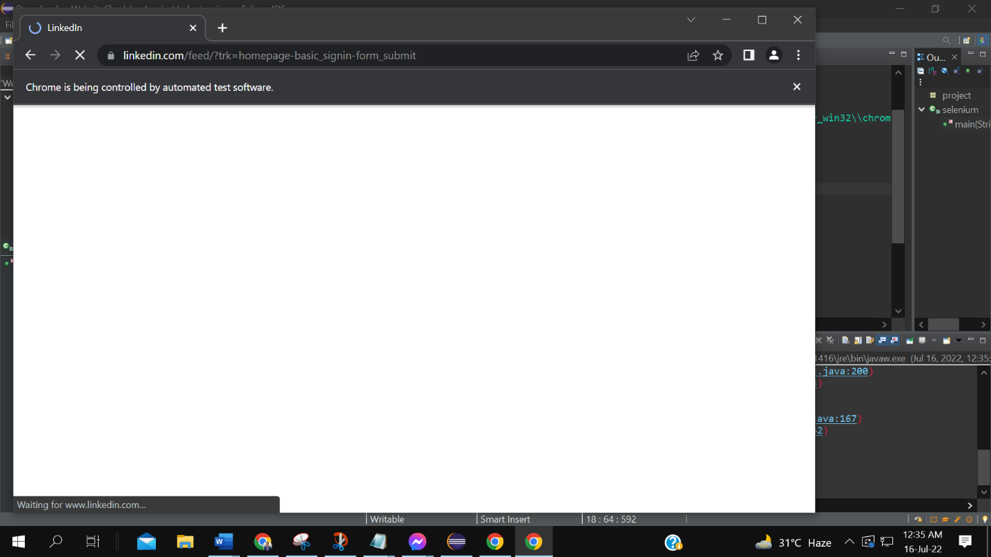

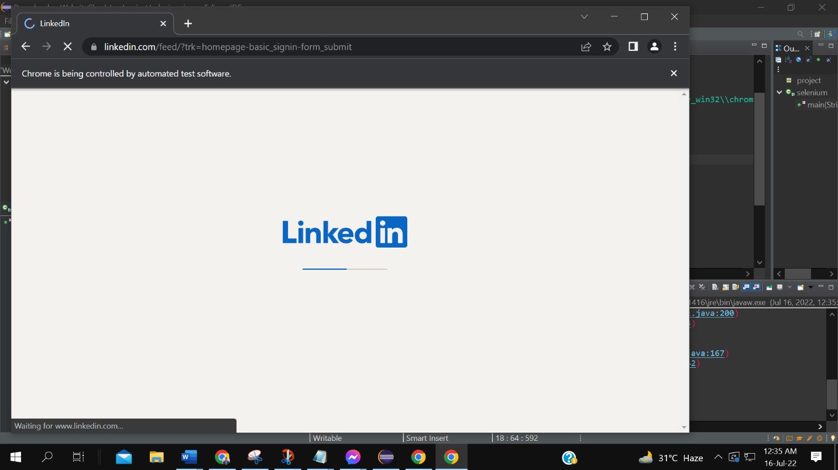

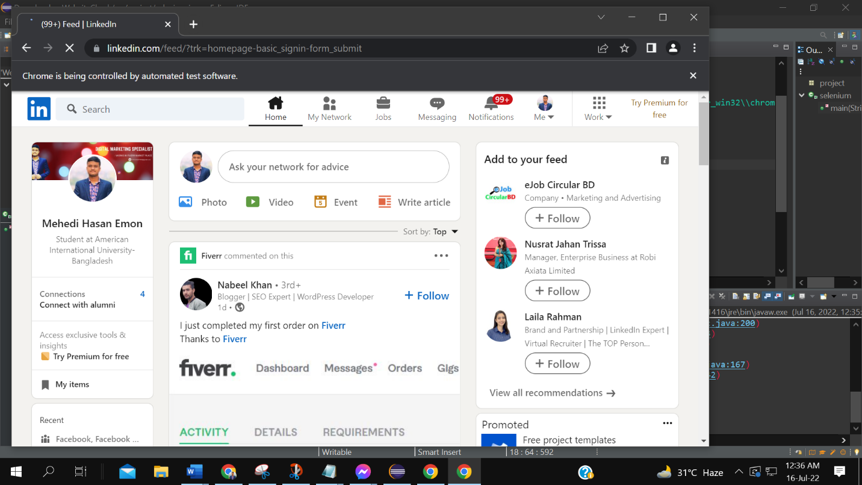

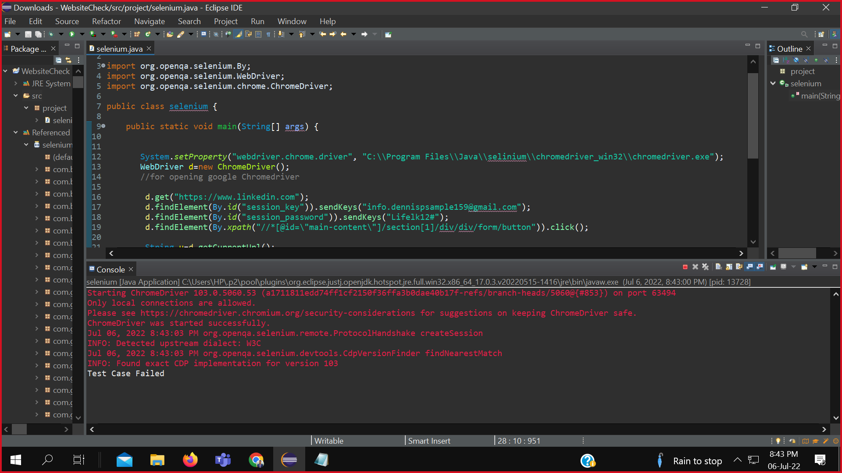



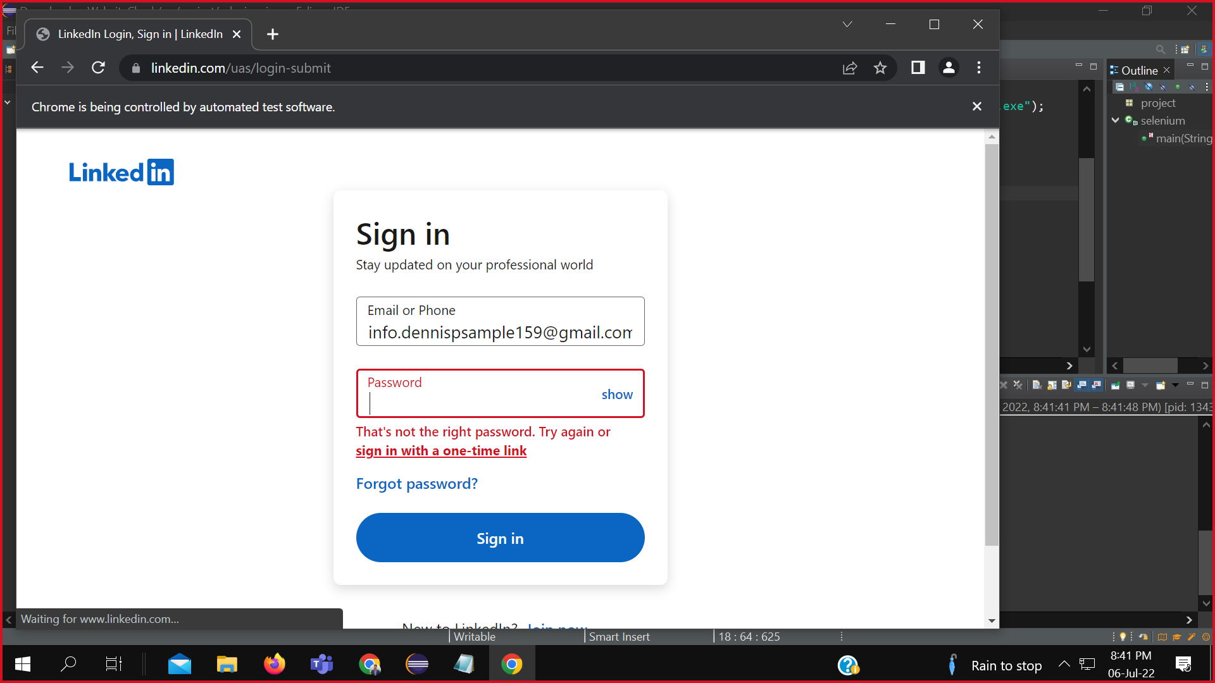

**TEST 2: GMAIL LOG IN TEST**

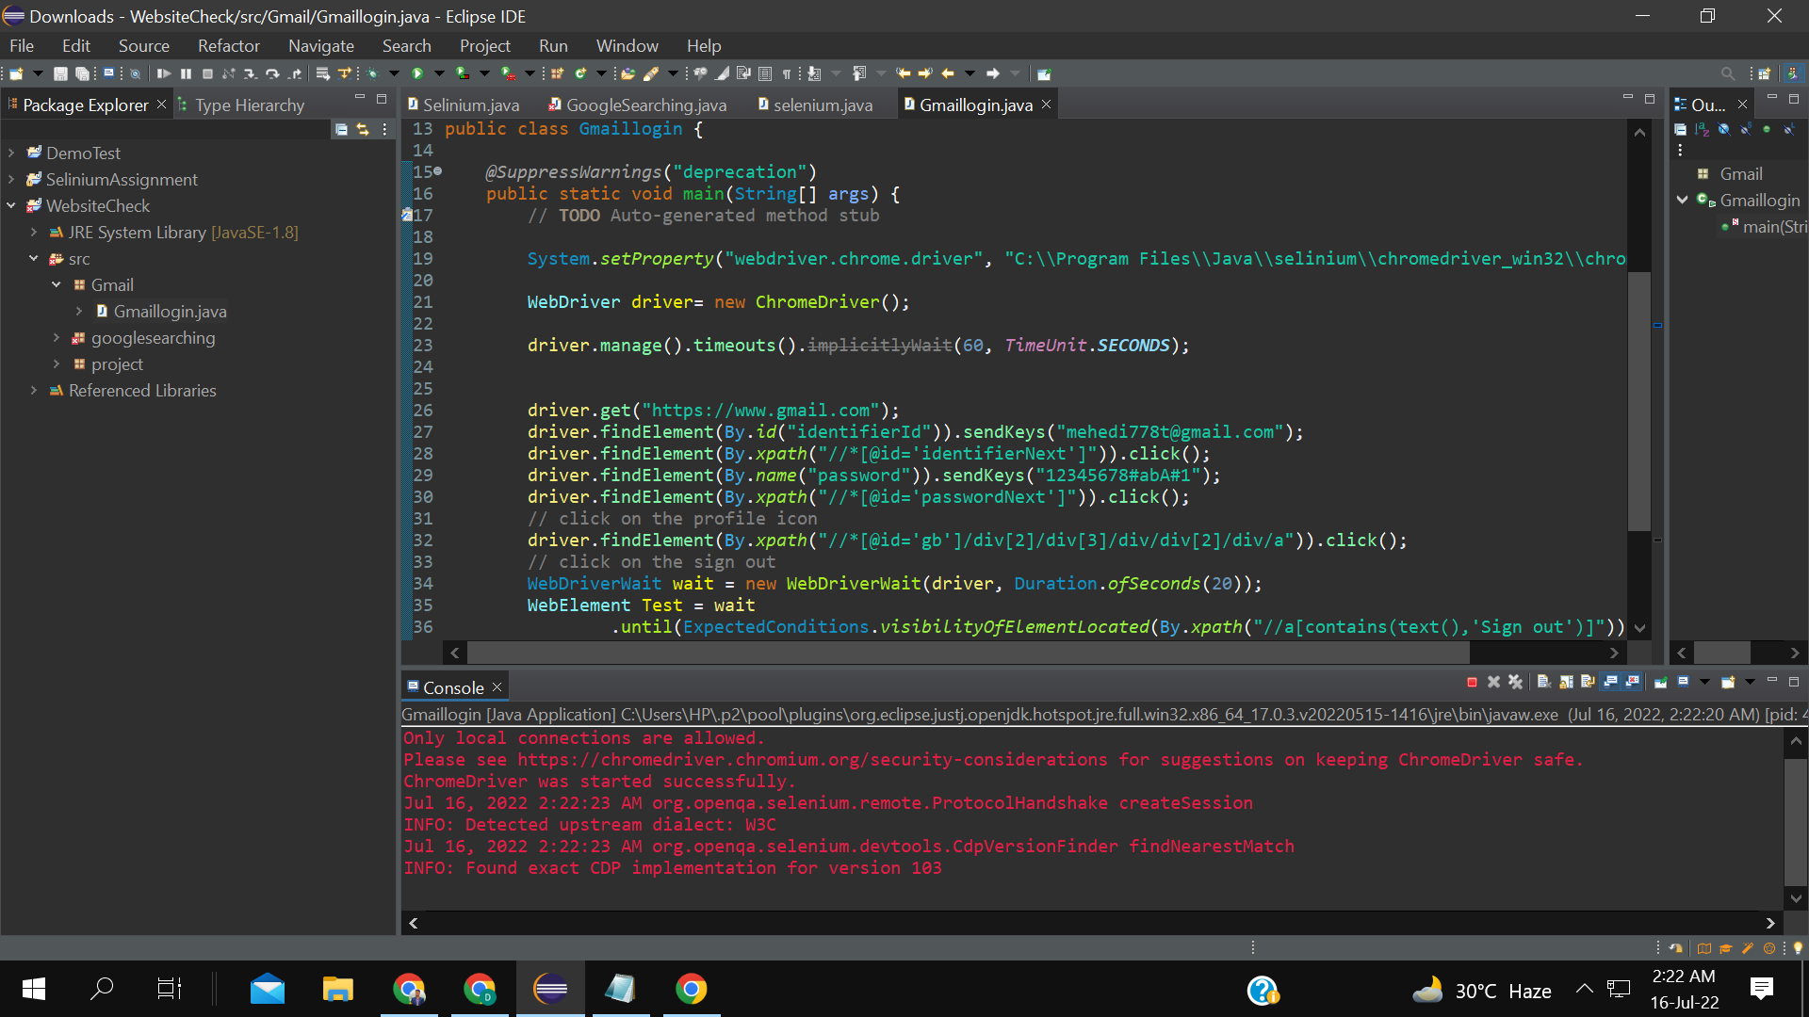

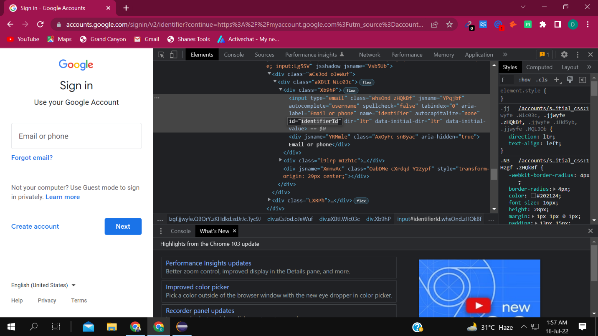

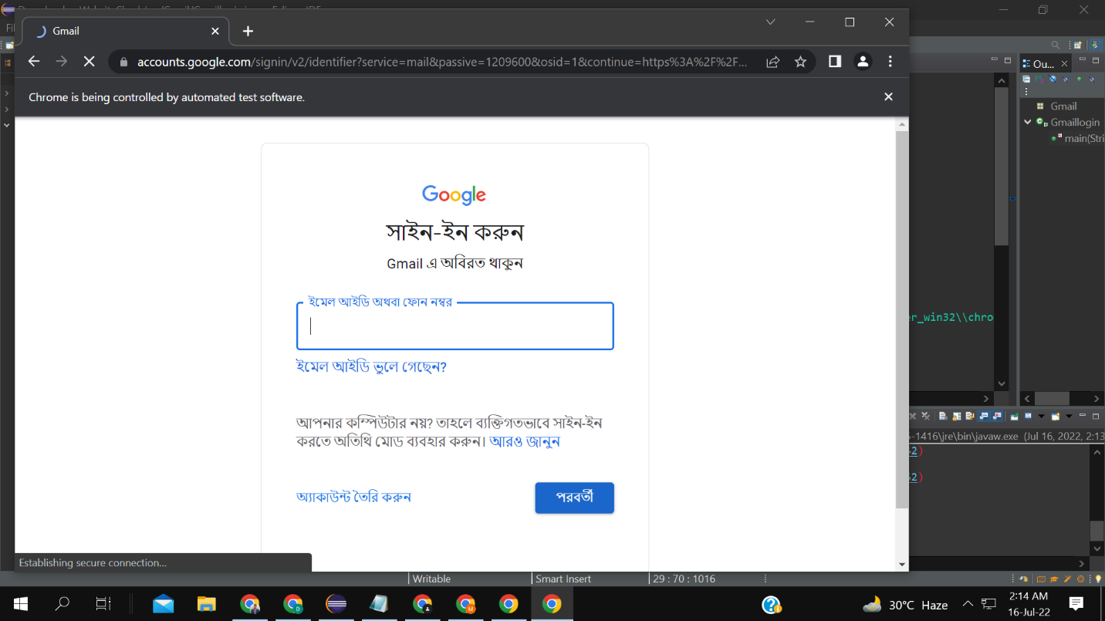

Gmail login testing with the presence of group members

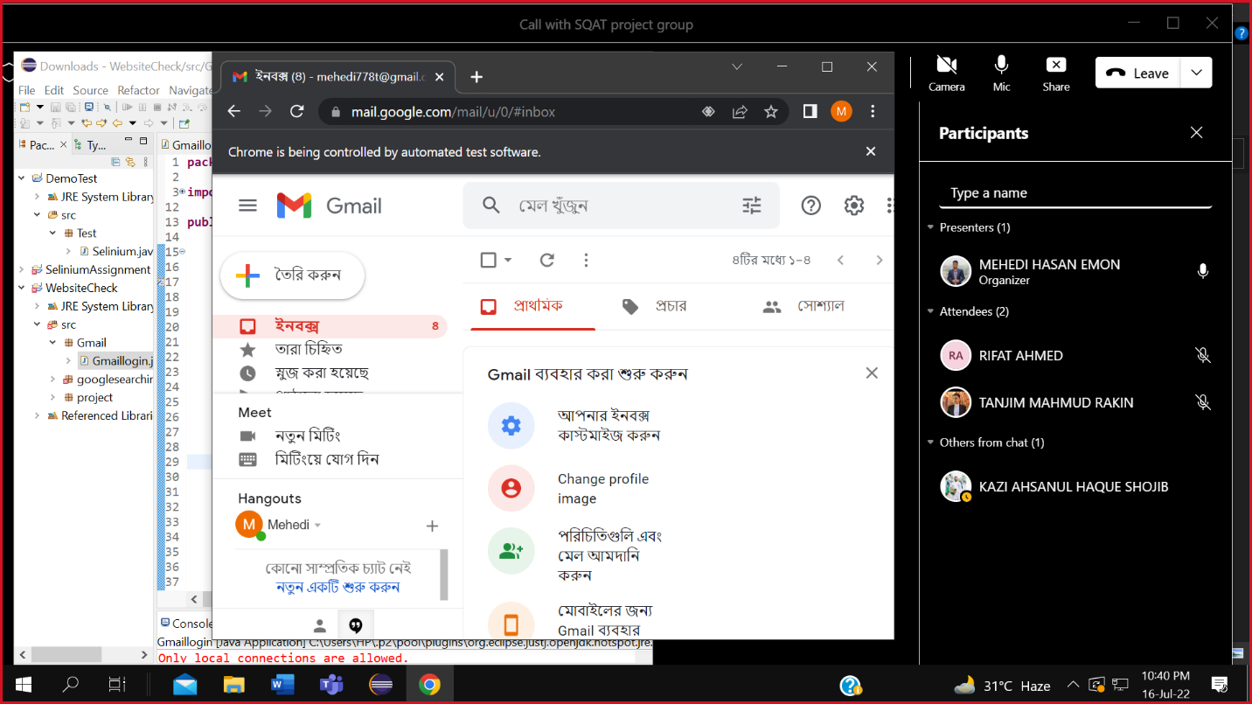

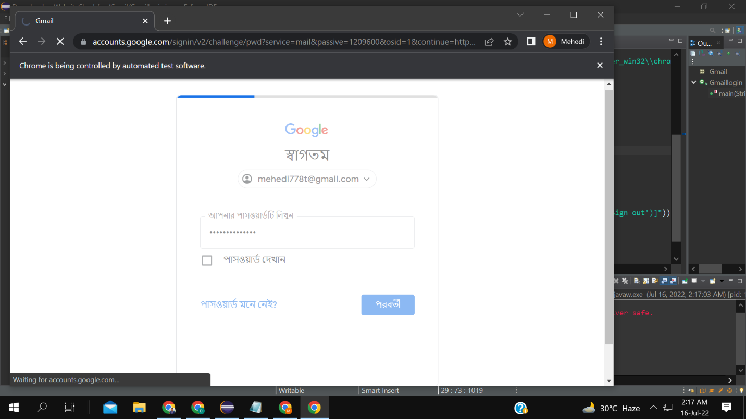

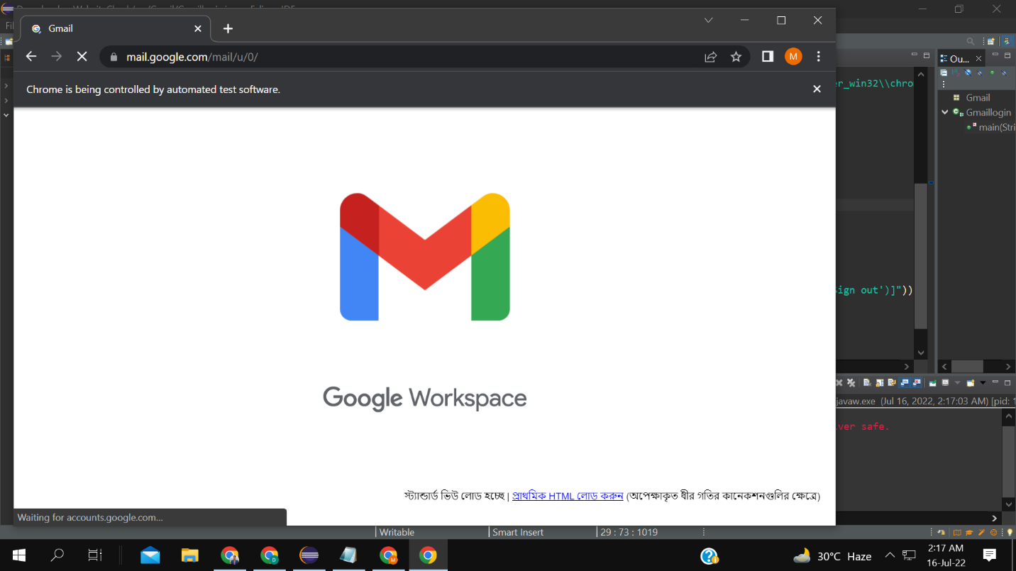

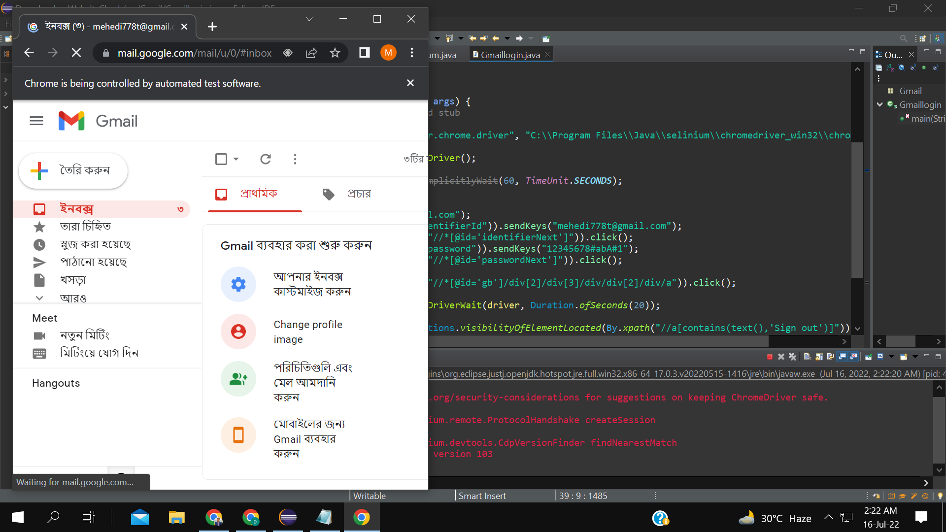

**FLOWCHART AND DESCRIPTION:**

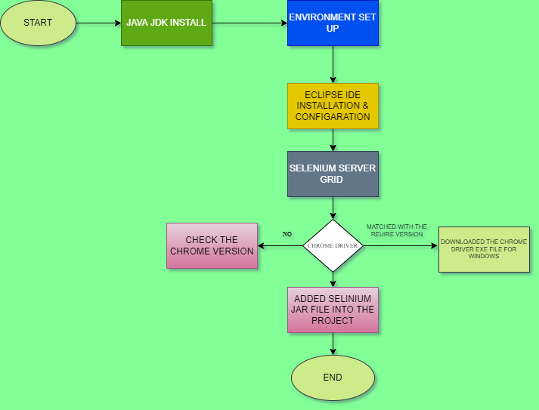

**Description:**

First, we need to download the jdk and Jre file. Then we need to set-up the environment variable for the Java. We have downloaded the Eclipse IDE for Java. After Downloading the eclipse IDE. We need to download the selenium grid server. We also downloaded the Chrome driver. For Chrome driver We need to check the Chrome version. According to the chrome version, we have downloaded the Chrome driver exe file. Then we just simply open the eclipse IDE. we need to set-up the selenium jar file into the eclipse ide. For that we need to go to the project file then build path-configure build -add external jar -selenium jar file

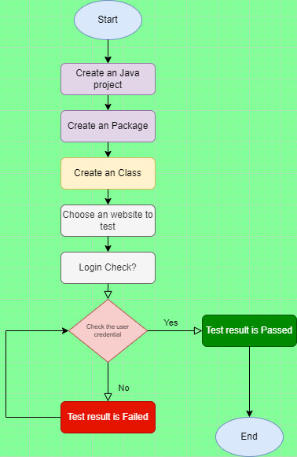

**Description:**

**First, we must open the Eclipse IDE. Then we have created an project. Under the project file, we have created an package, then we have created an class. For testing purpose, we have choosen LinkedIn Website. The test result was passed whenever the email and password are matched. If the username and password didn’t match the test result was failed.**

**INTELLIJ IDEA INSTALL, CONFIGARATION, PROJECT CREATION:**

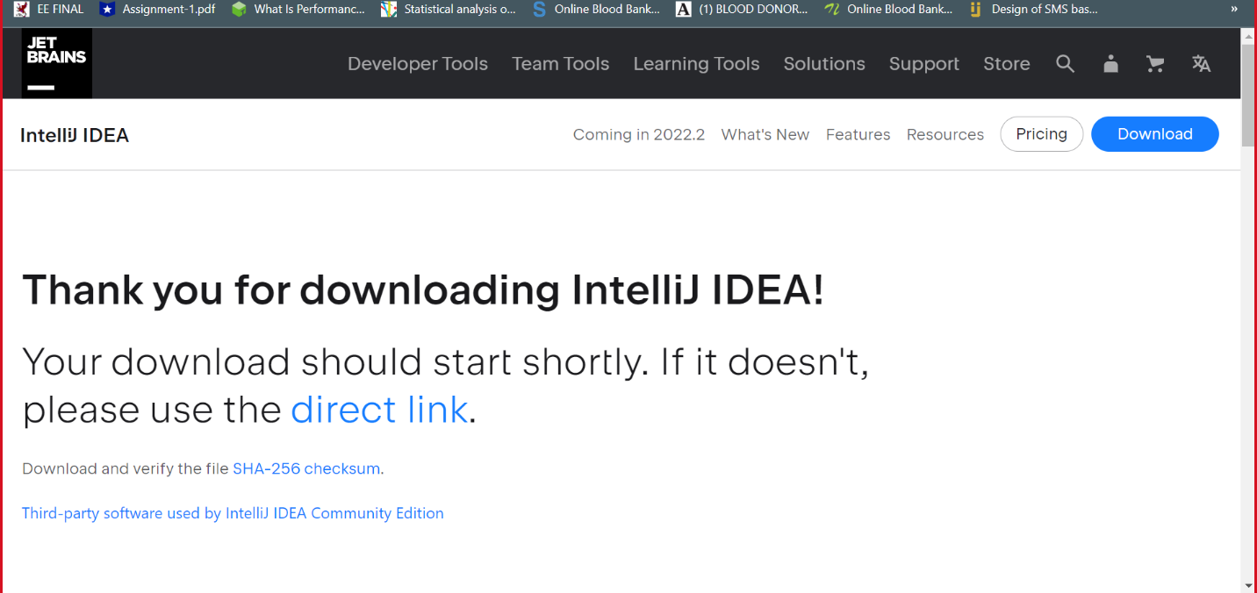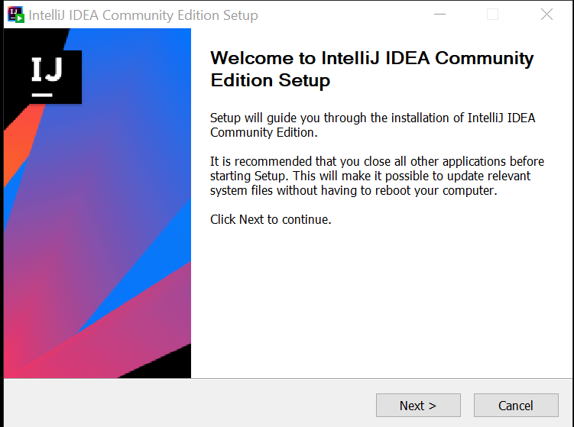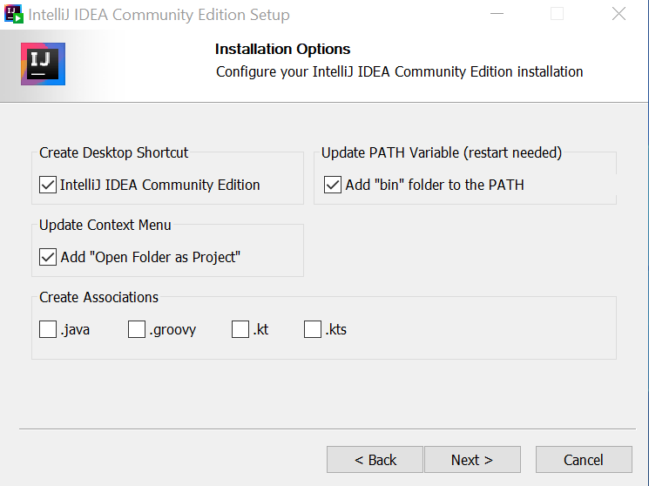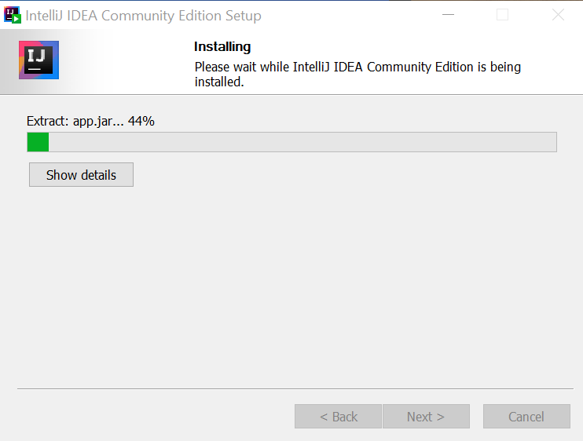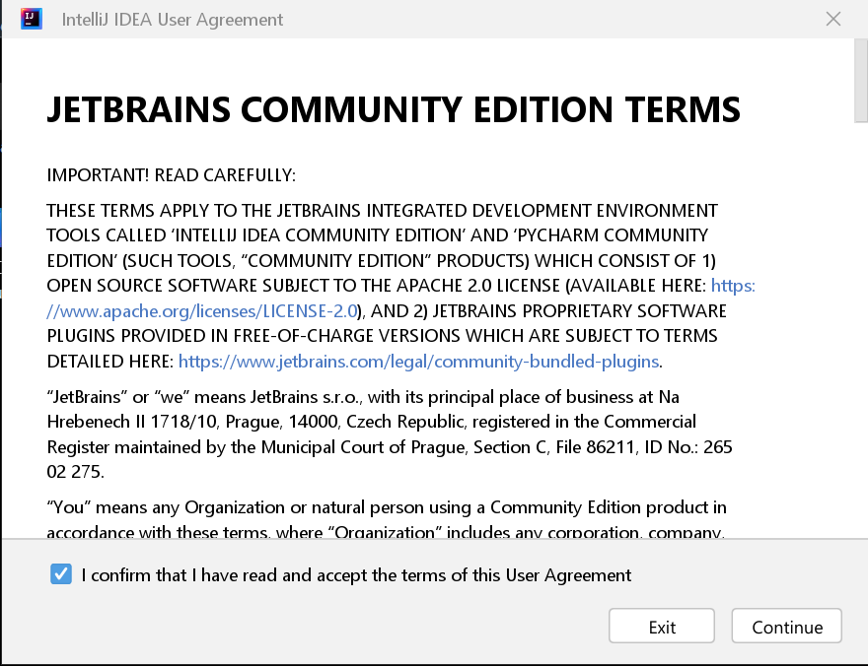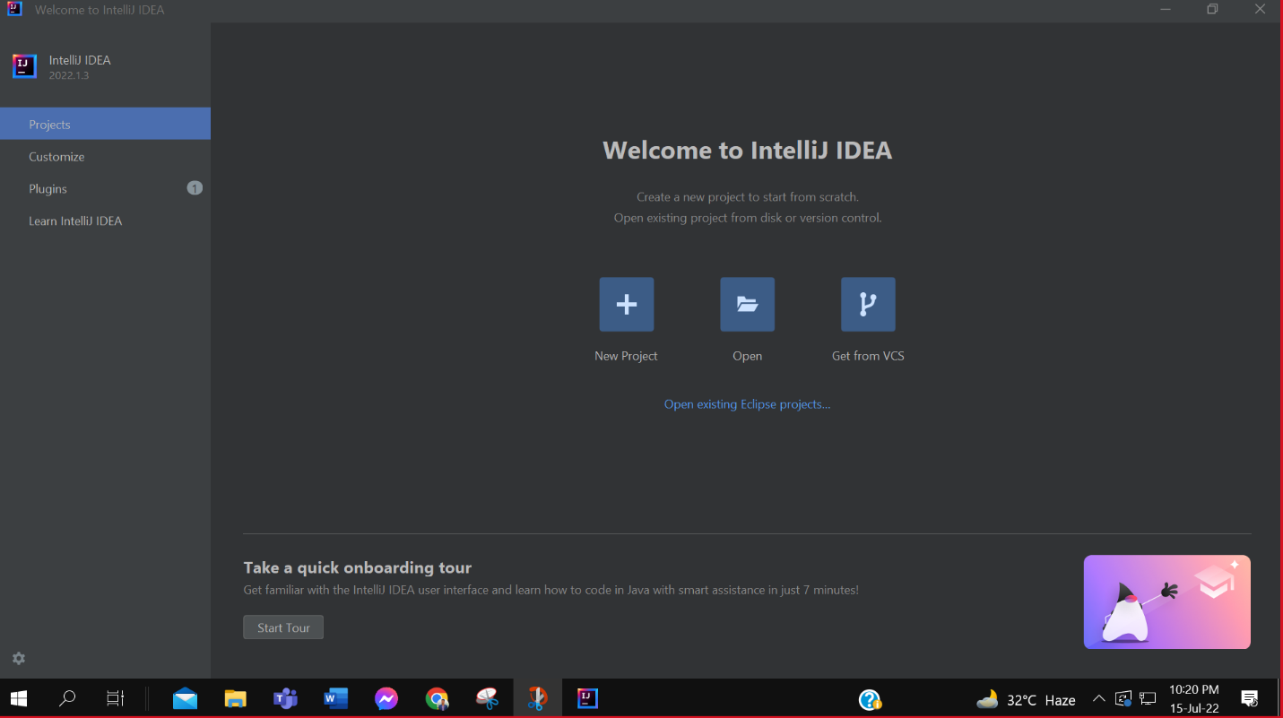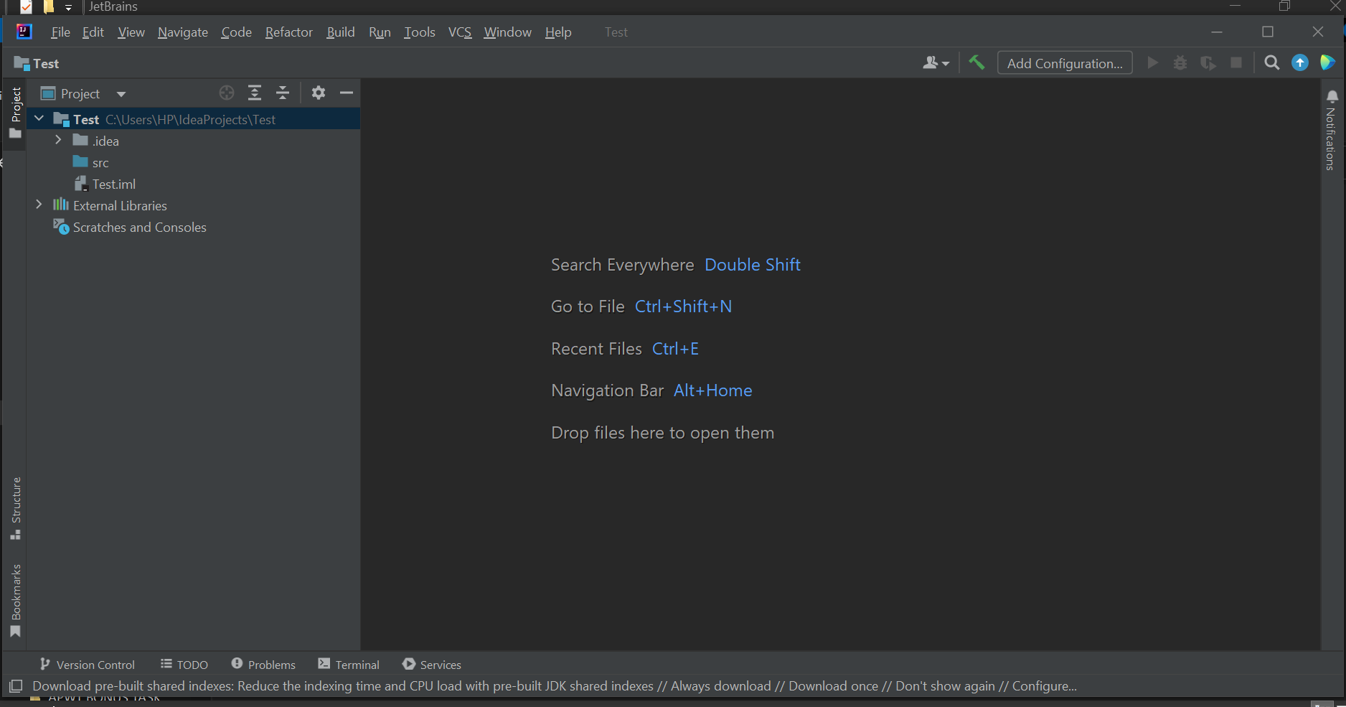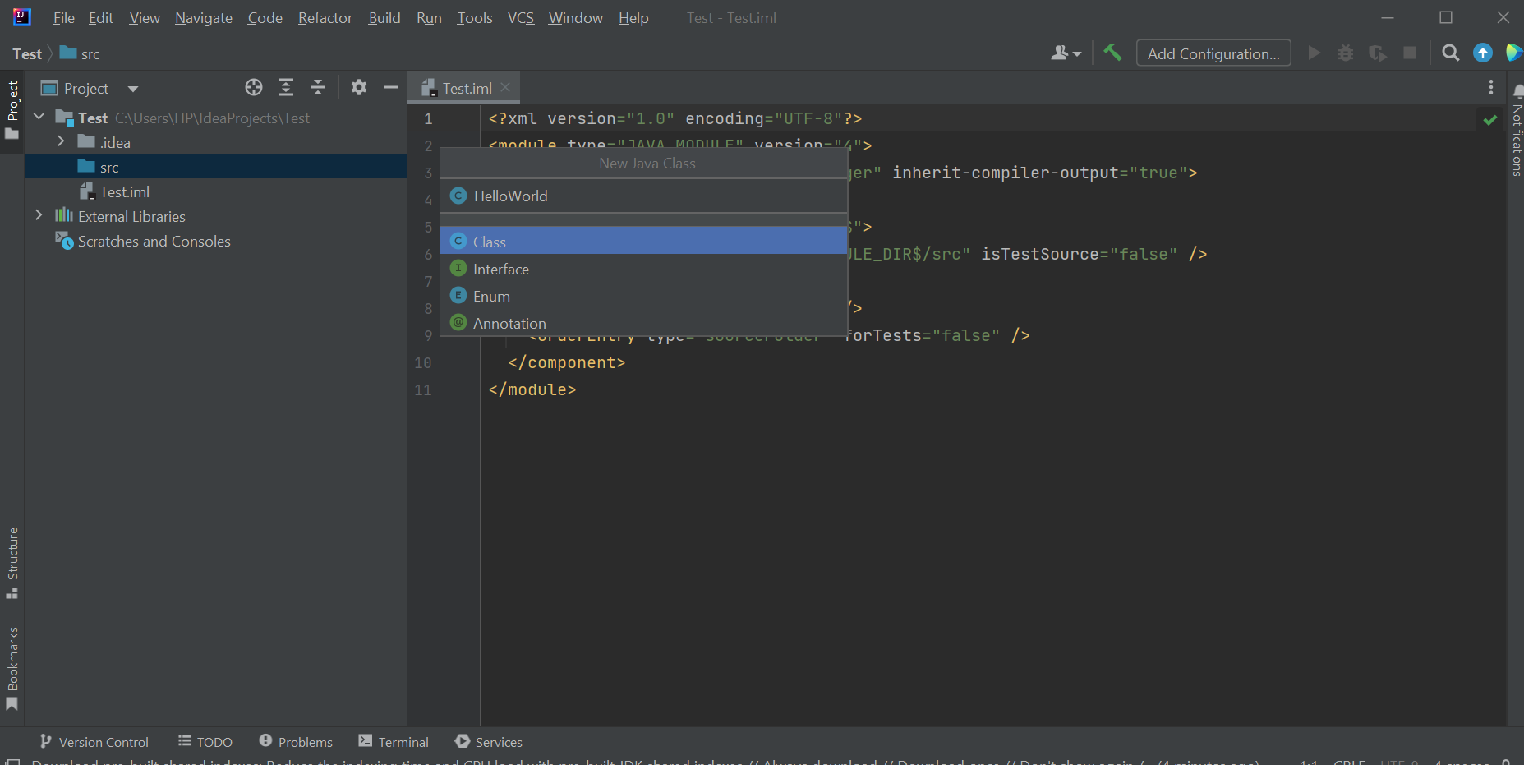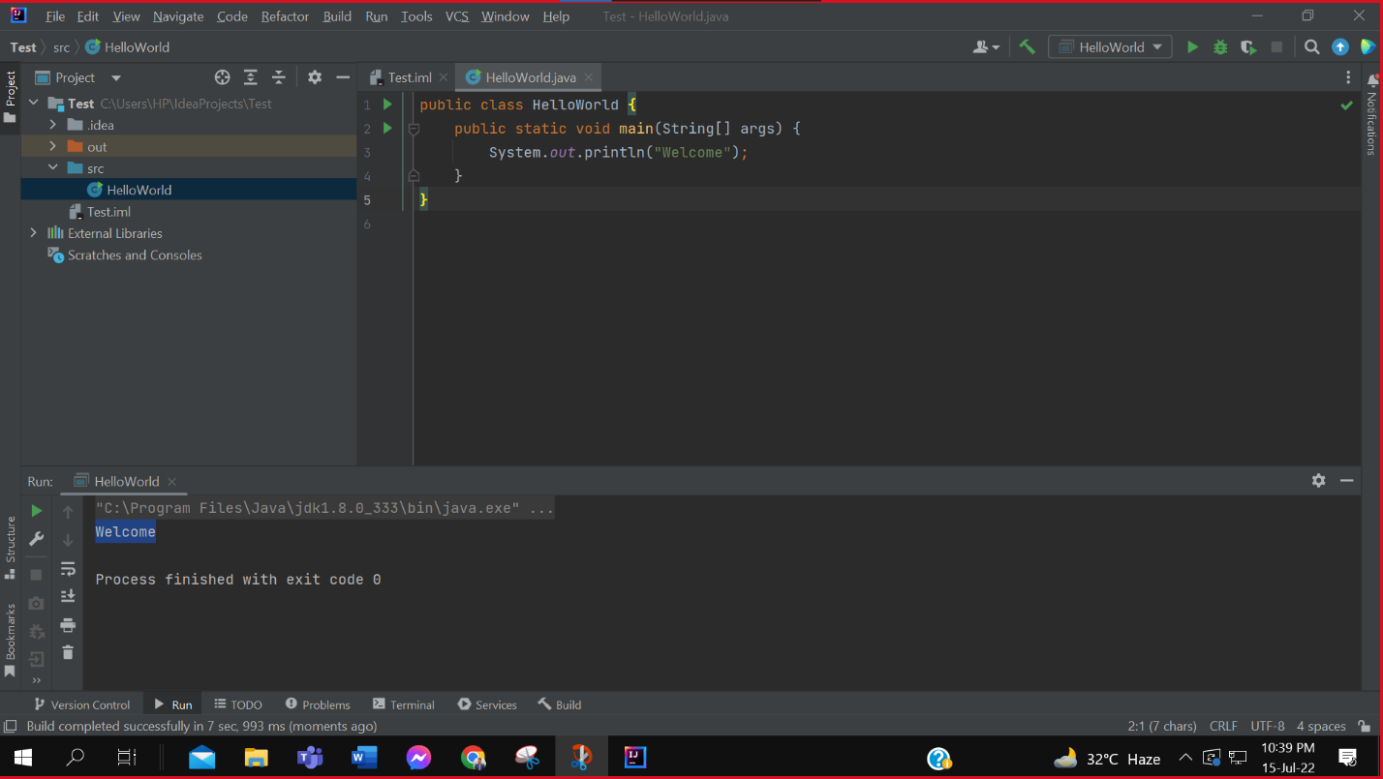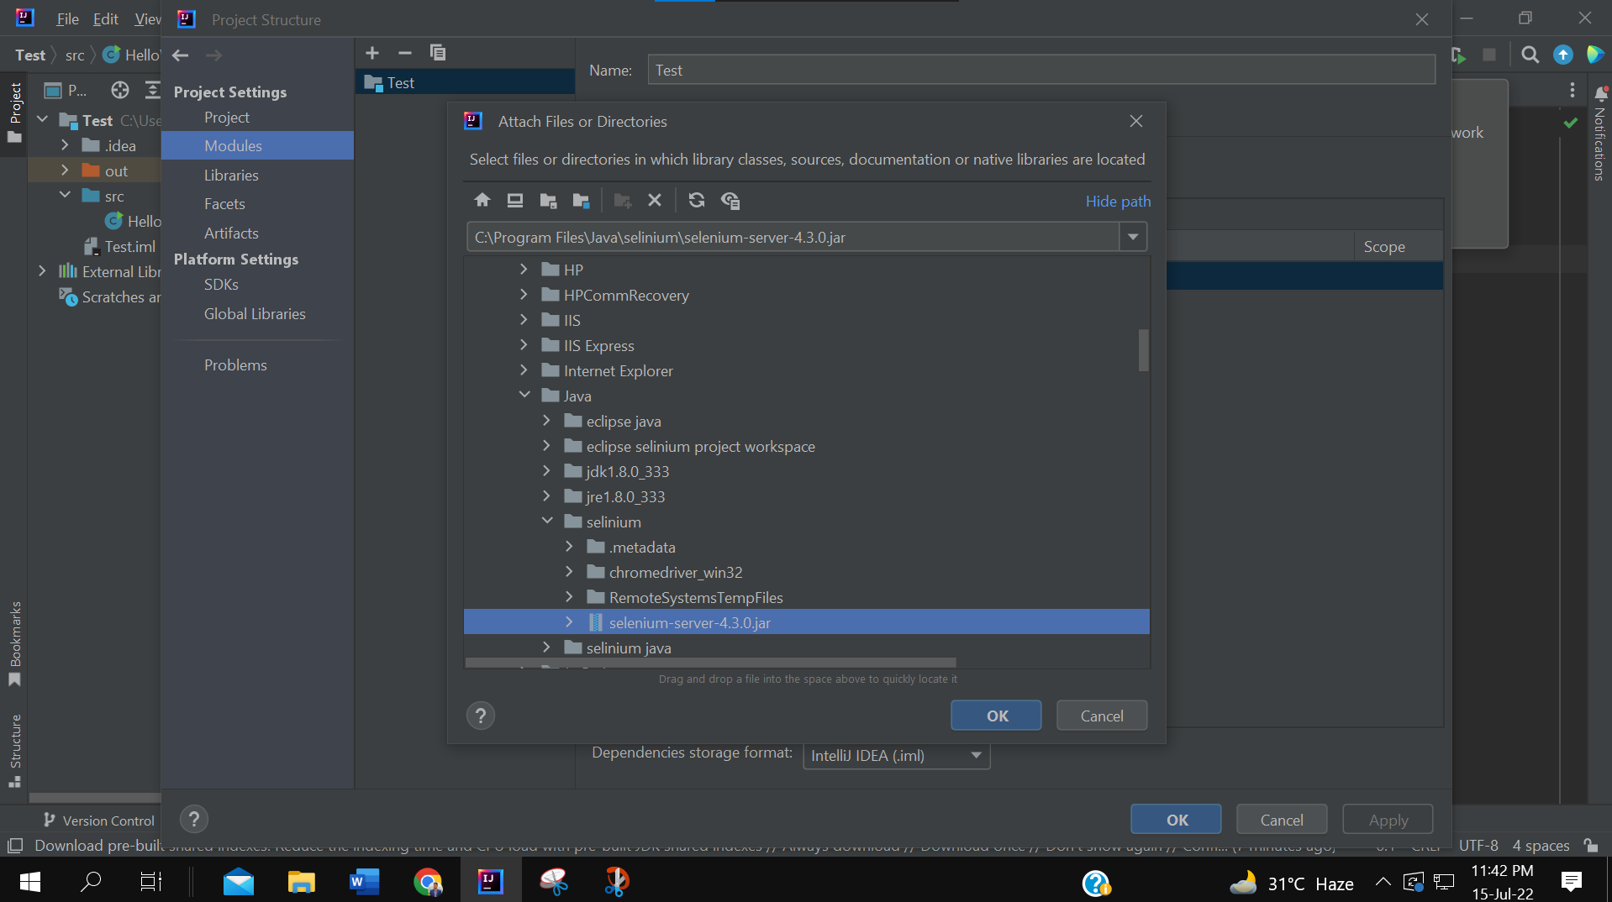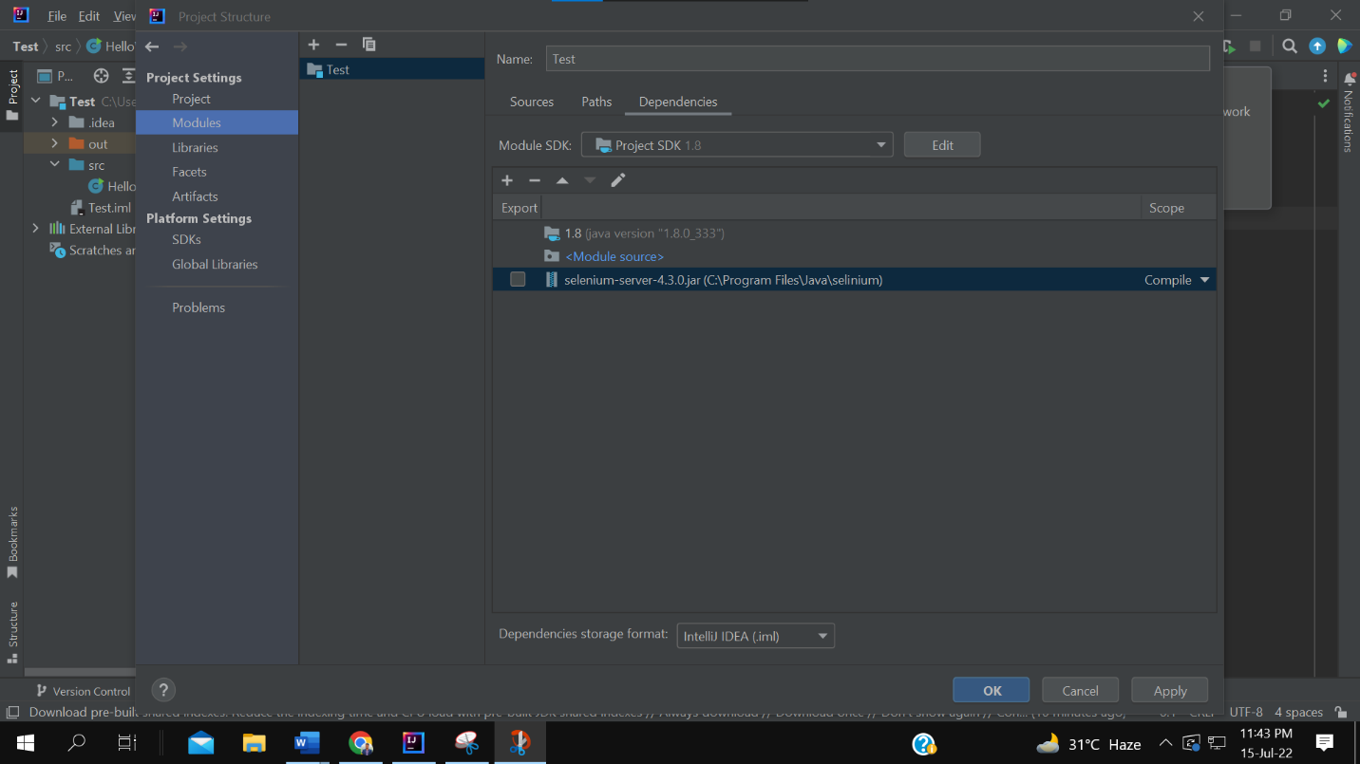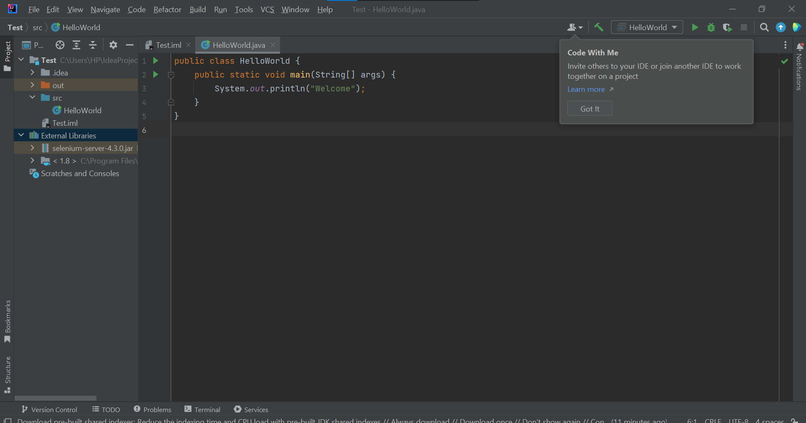

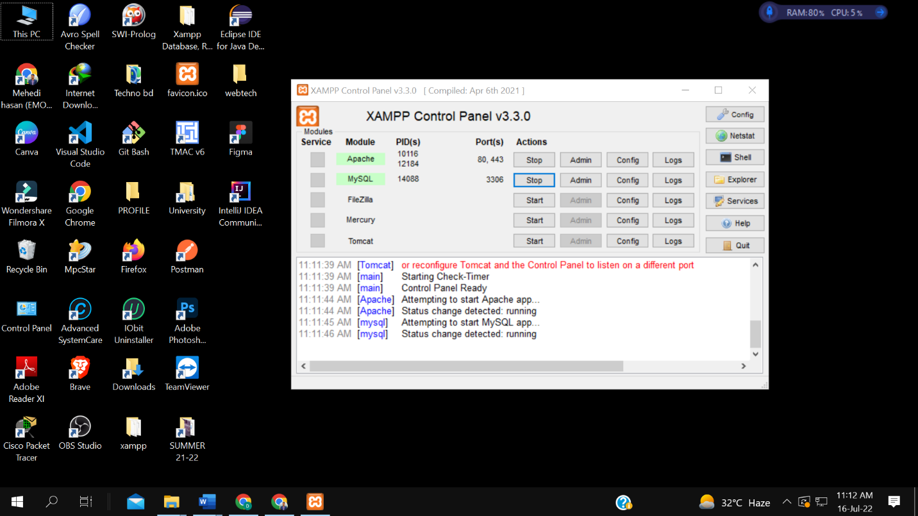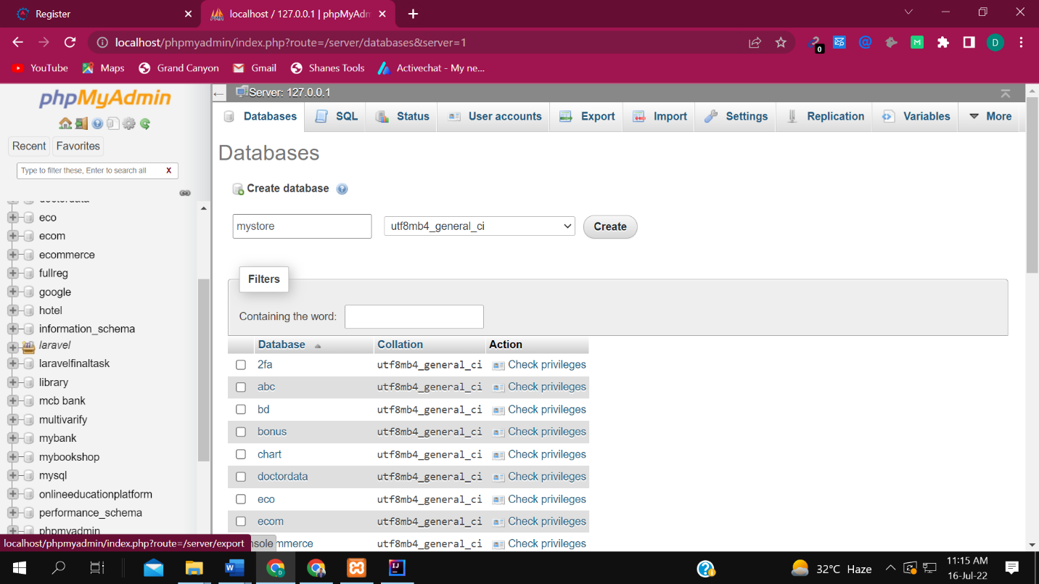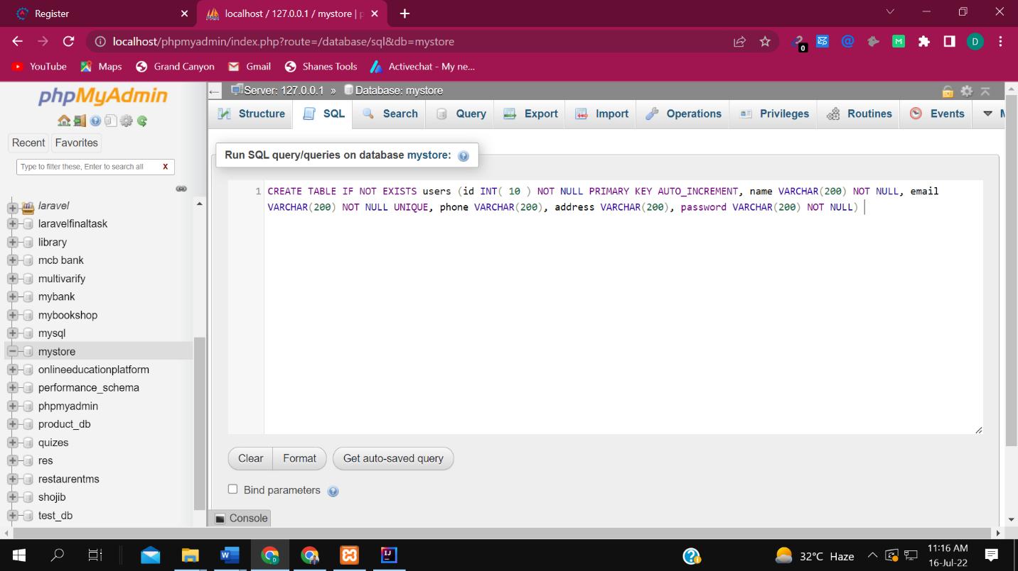

**JAVA, MY SQL DATABASE PROJECT CREATION AND TESTING WITH INTELLIJ IDEA**

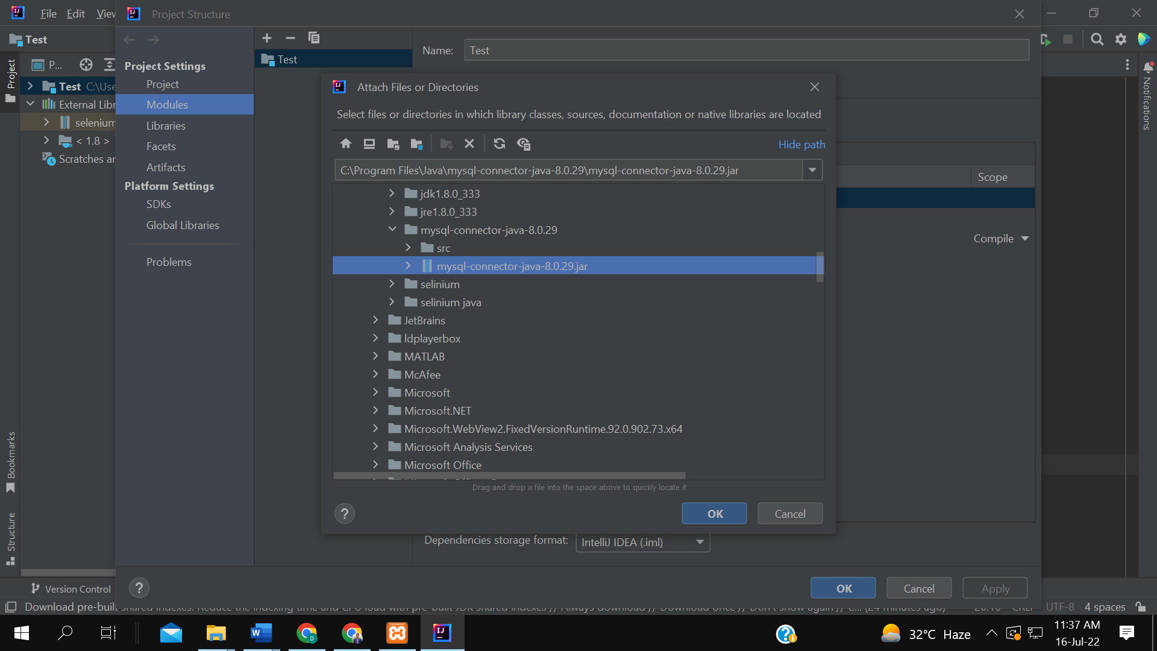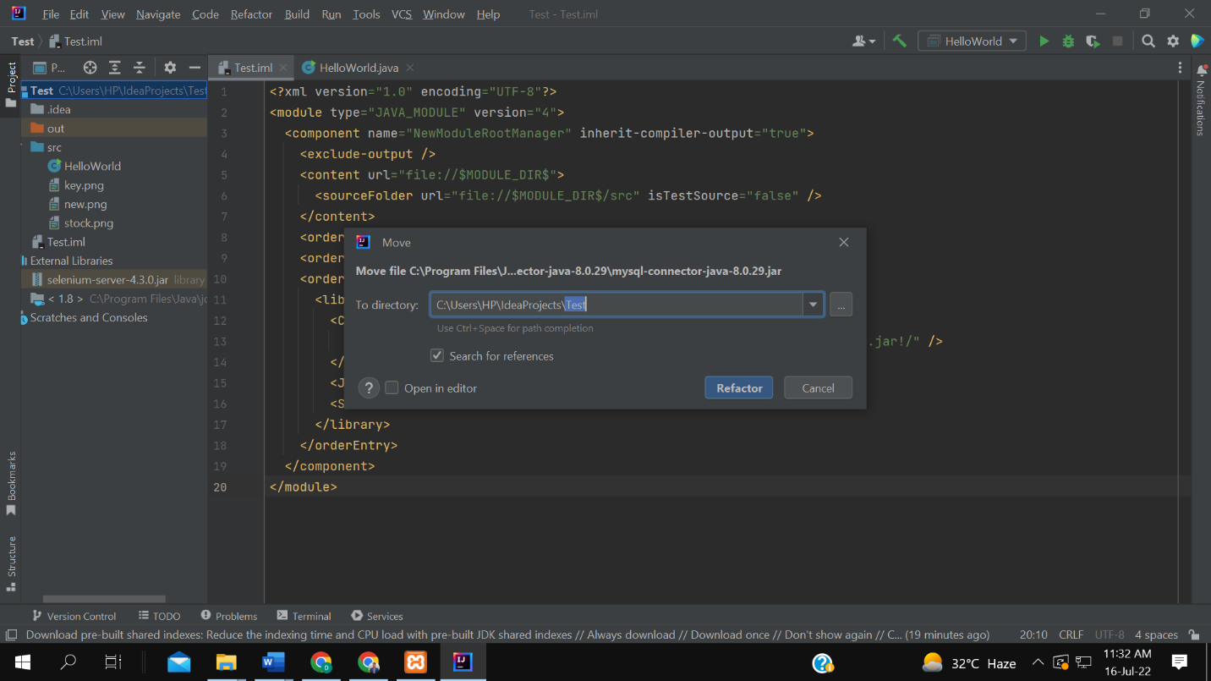

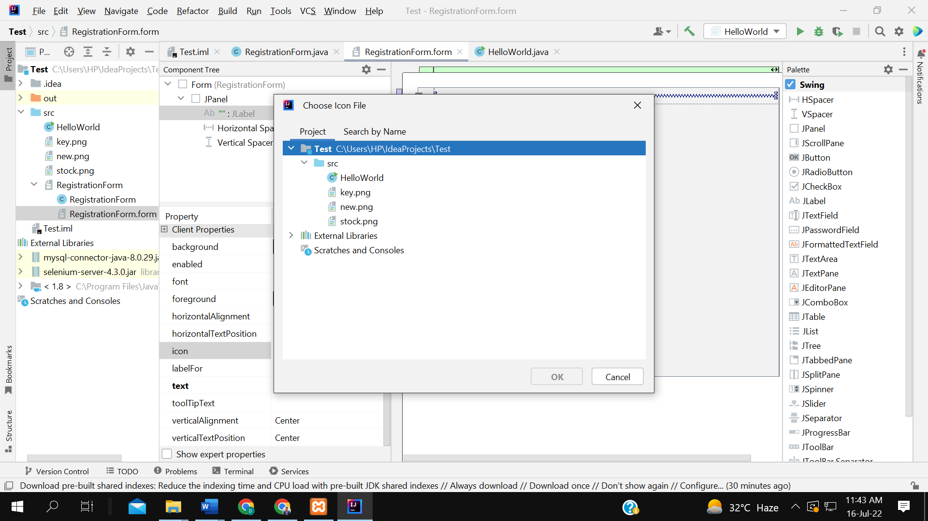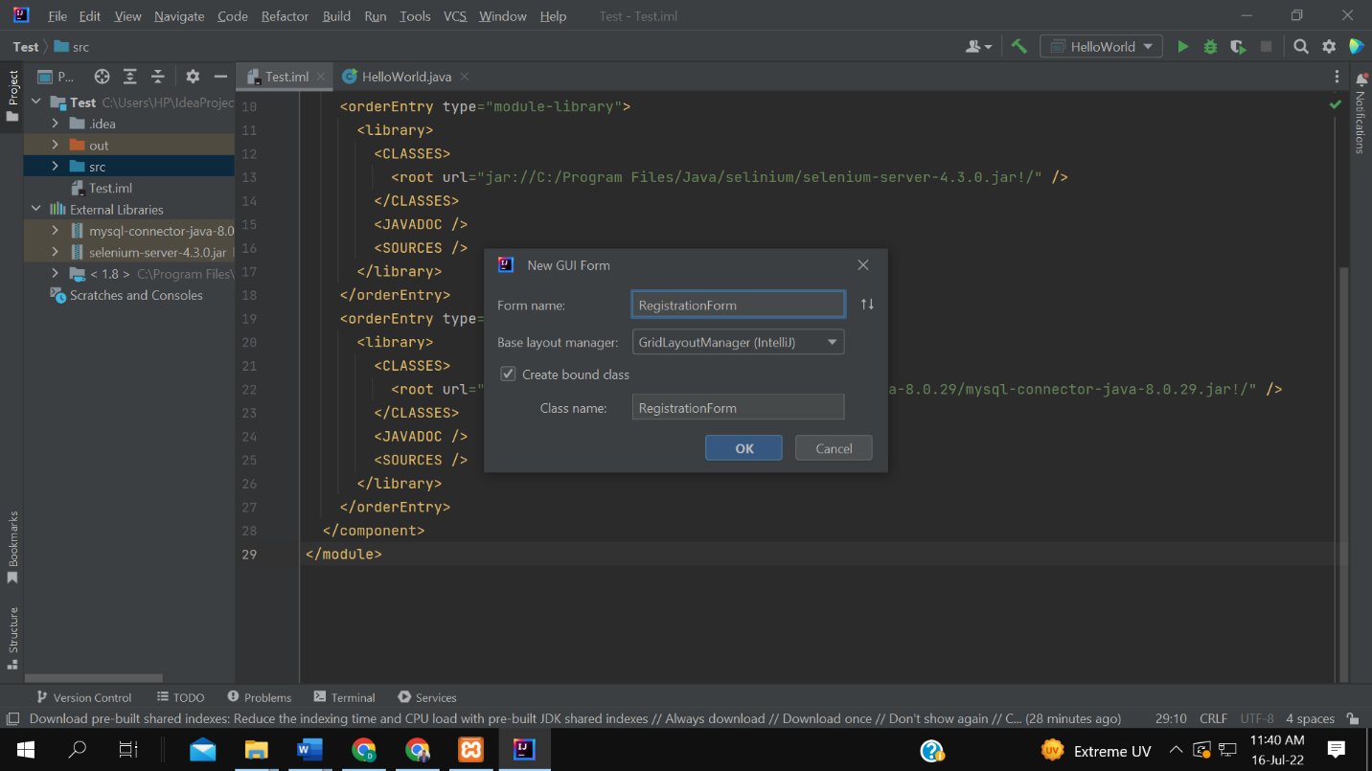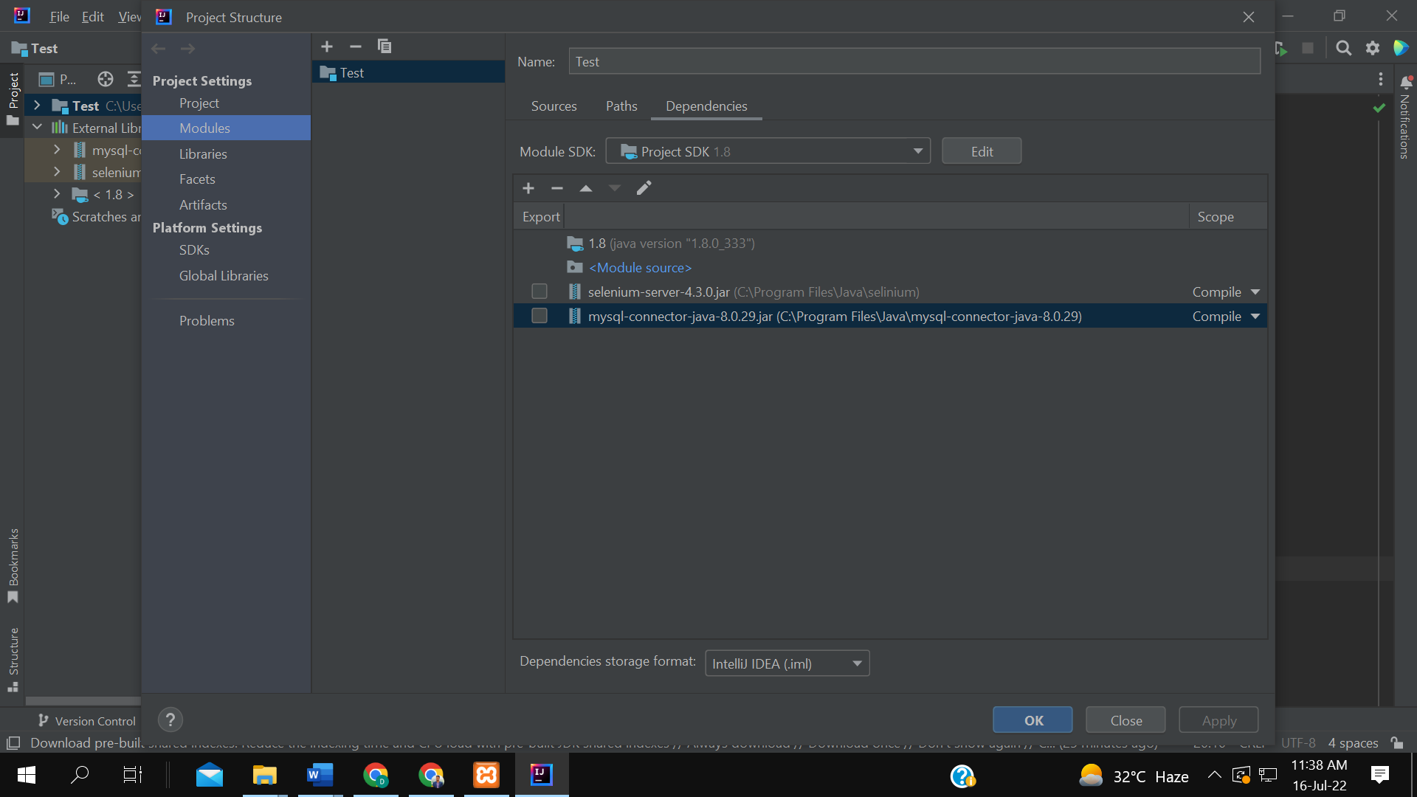



**REGISTRATION FORM:**

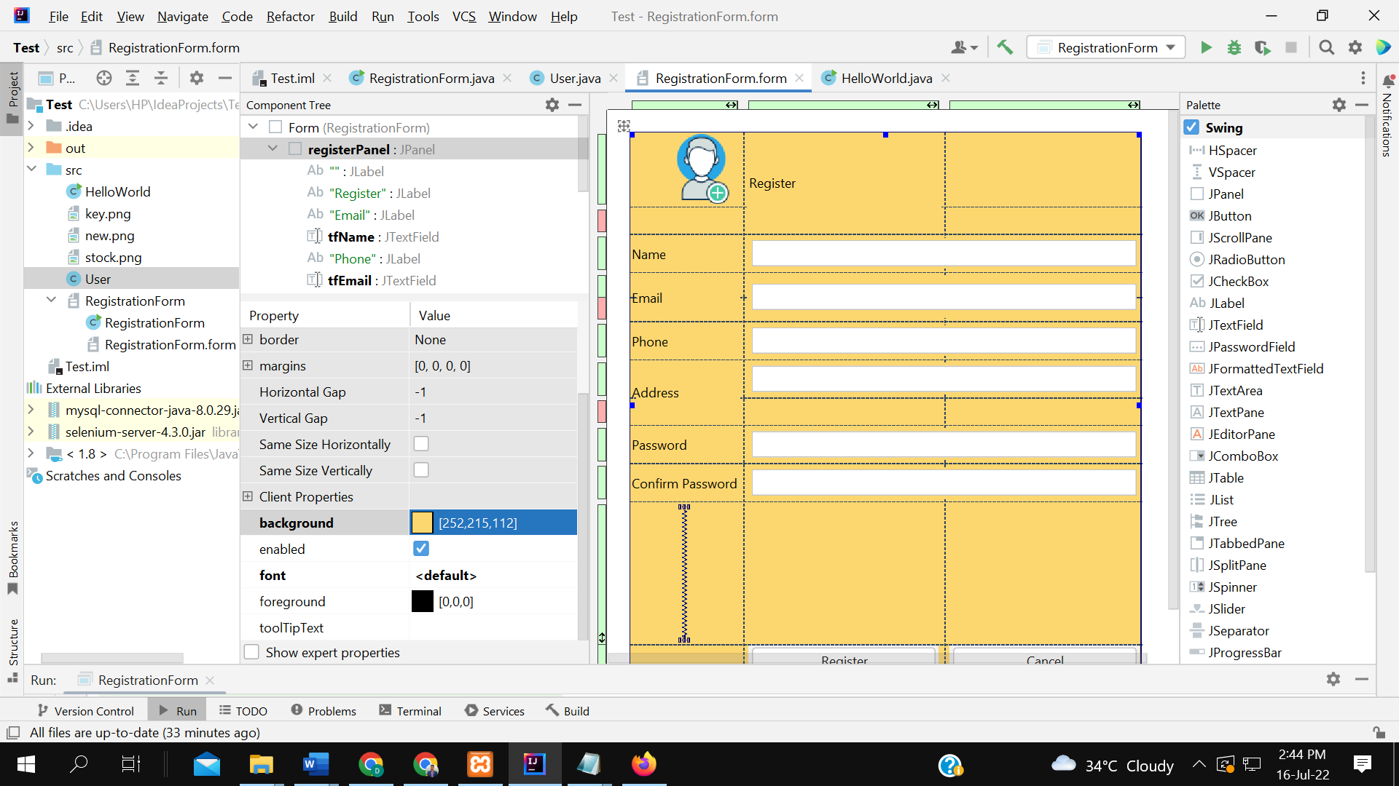

**FORM VALIDATION:**

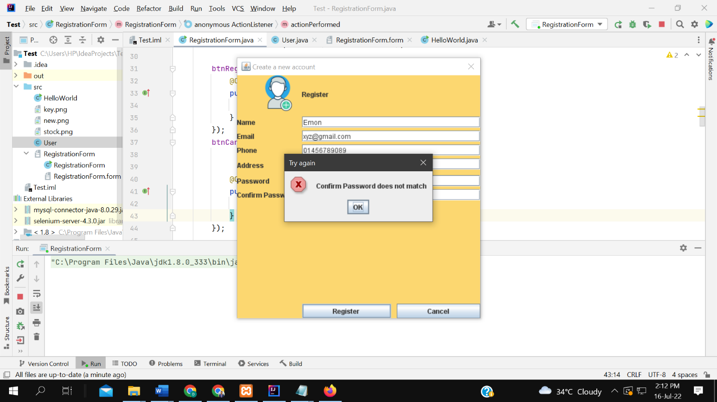

**TESTING RESULT:**

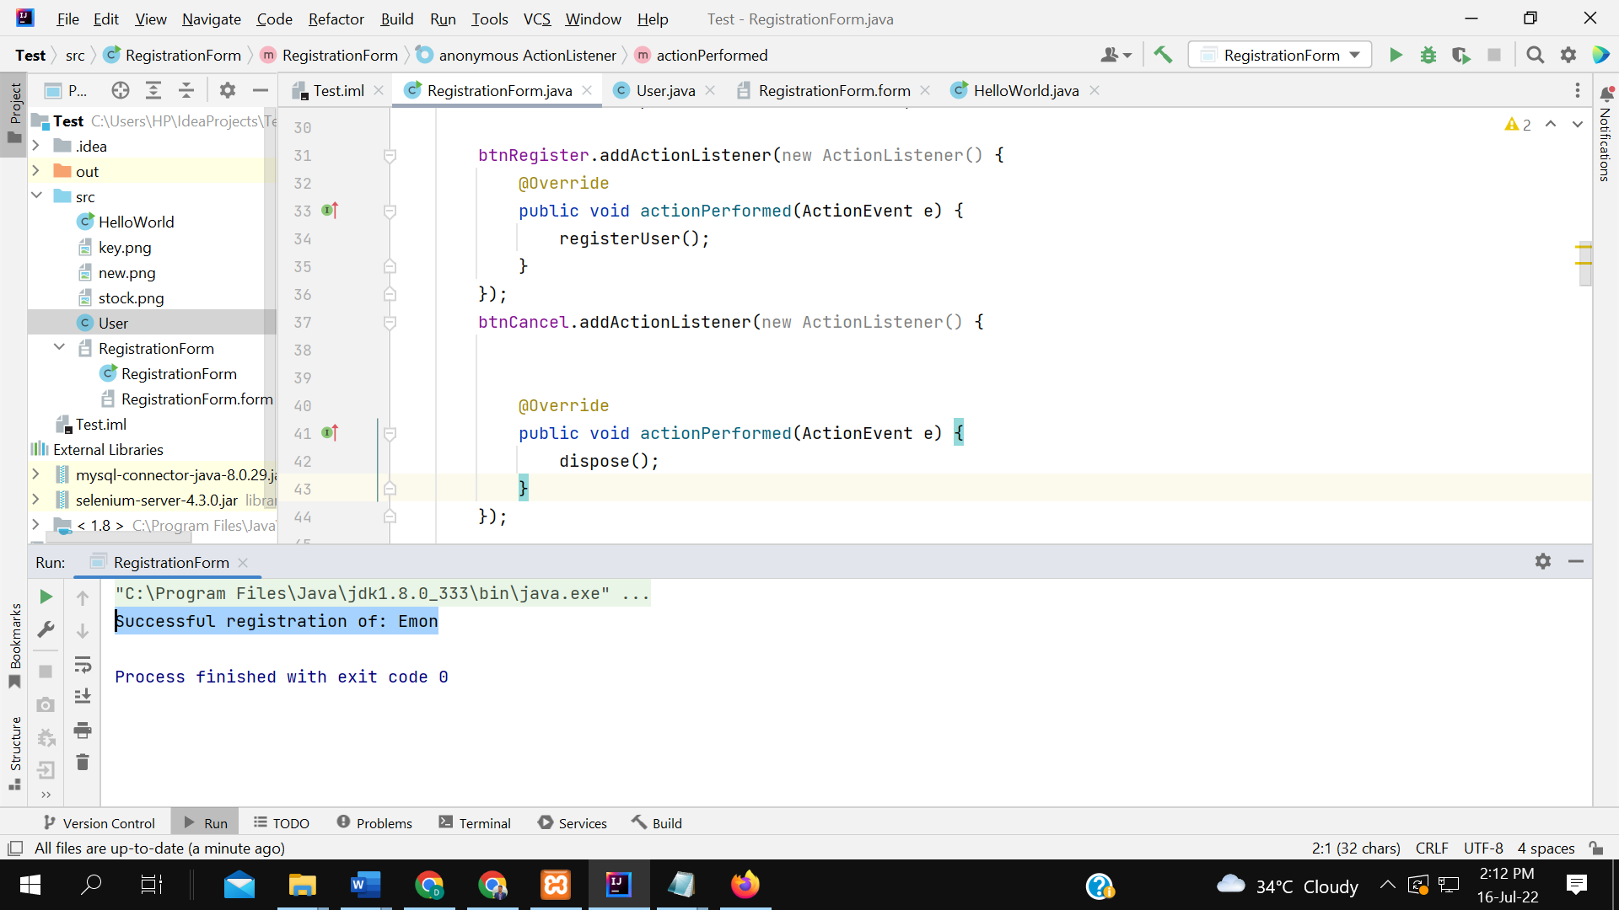

DATABASE CHECKING:

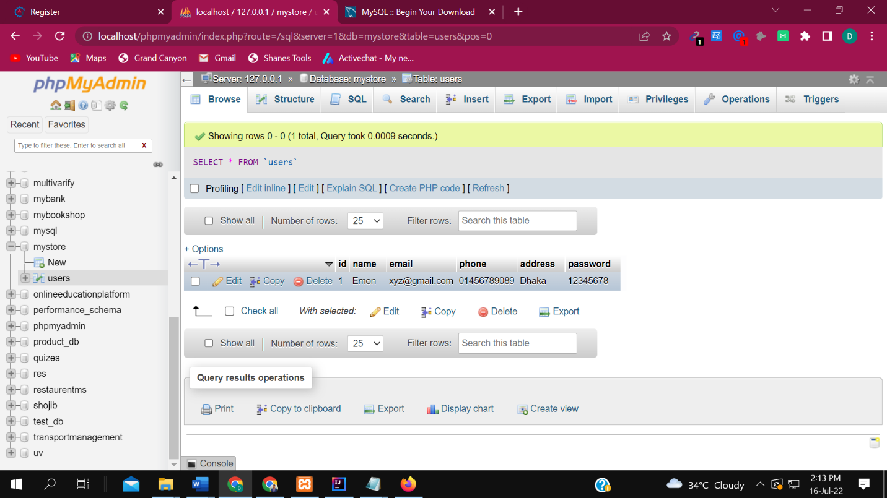

LOG IN TEST USING SAME INFO

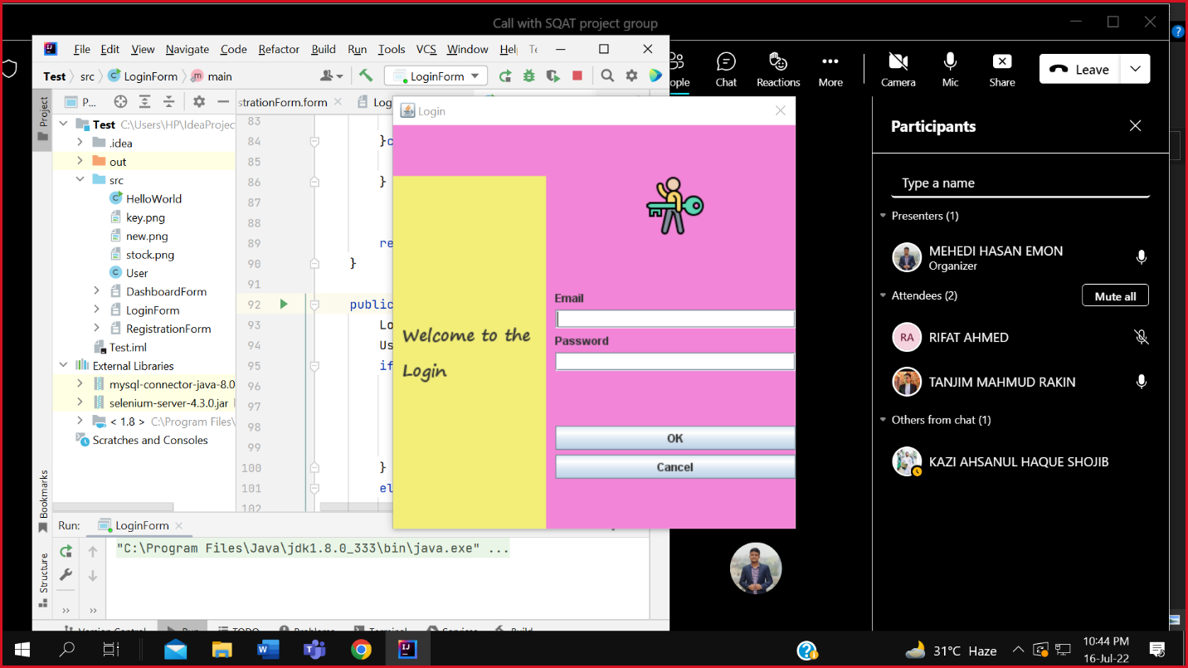

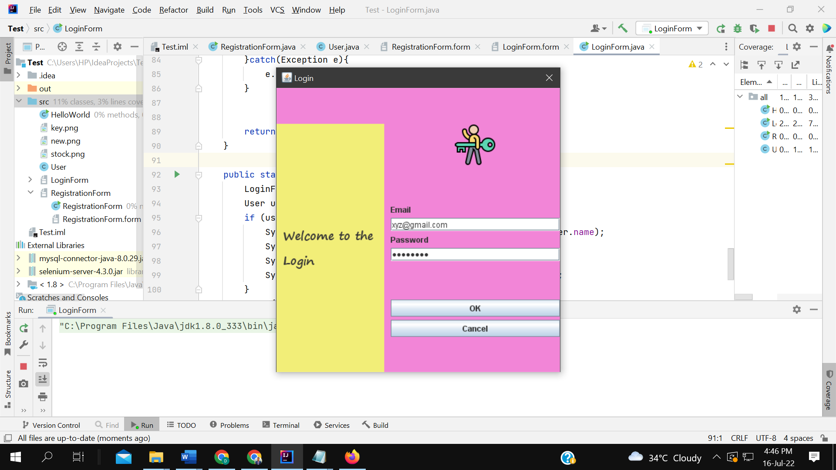

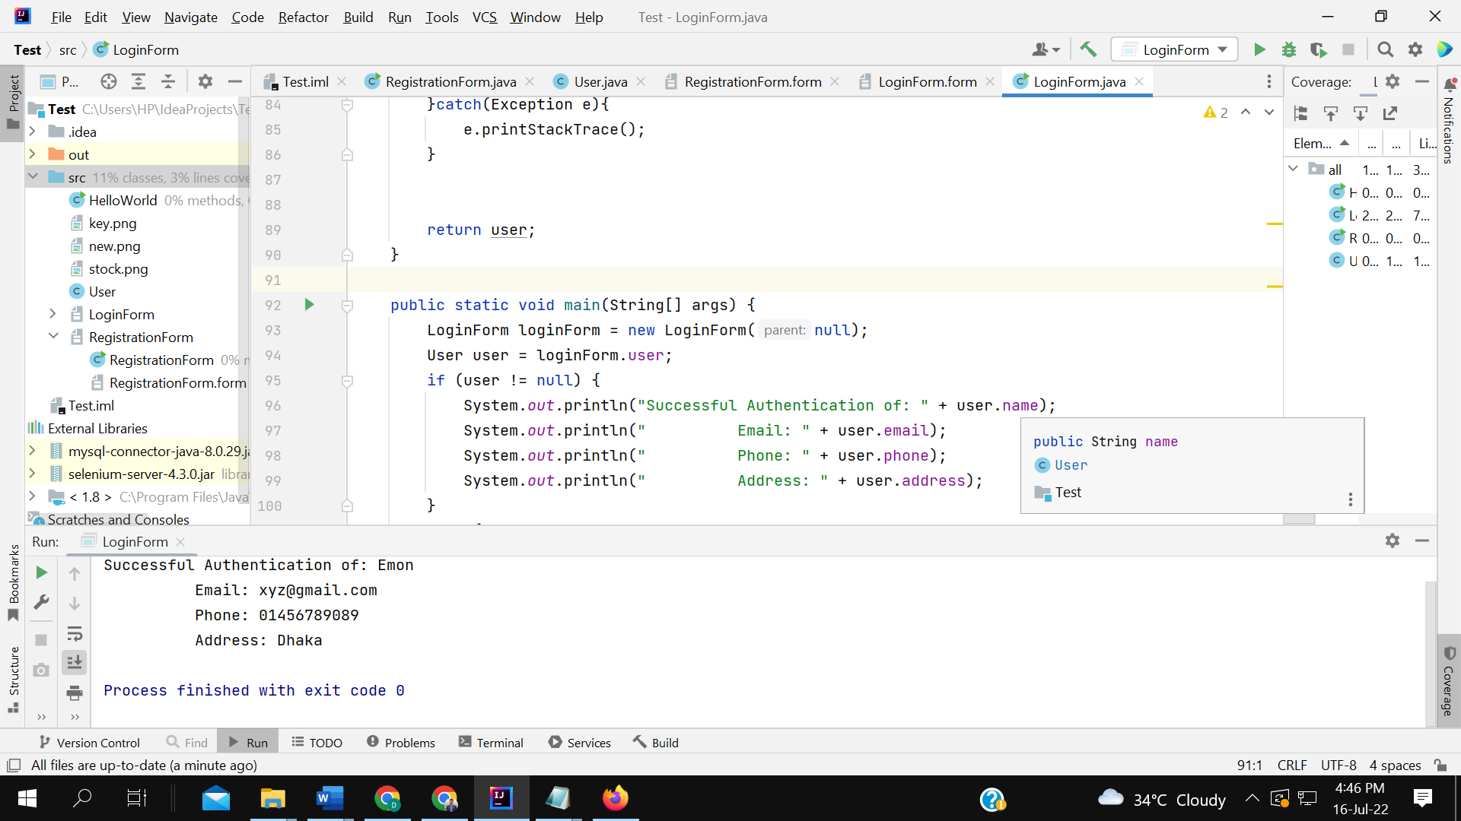

**RESULT: TEST SUCCESSFUL**

**DASHBOARD:**

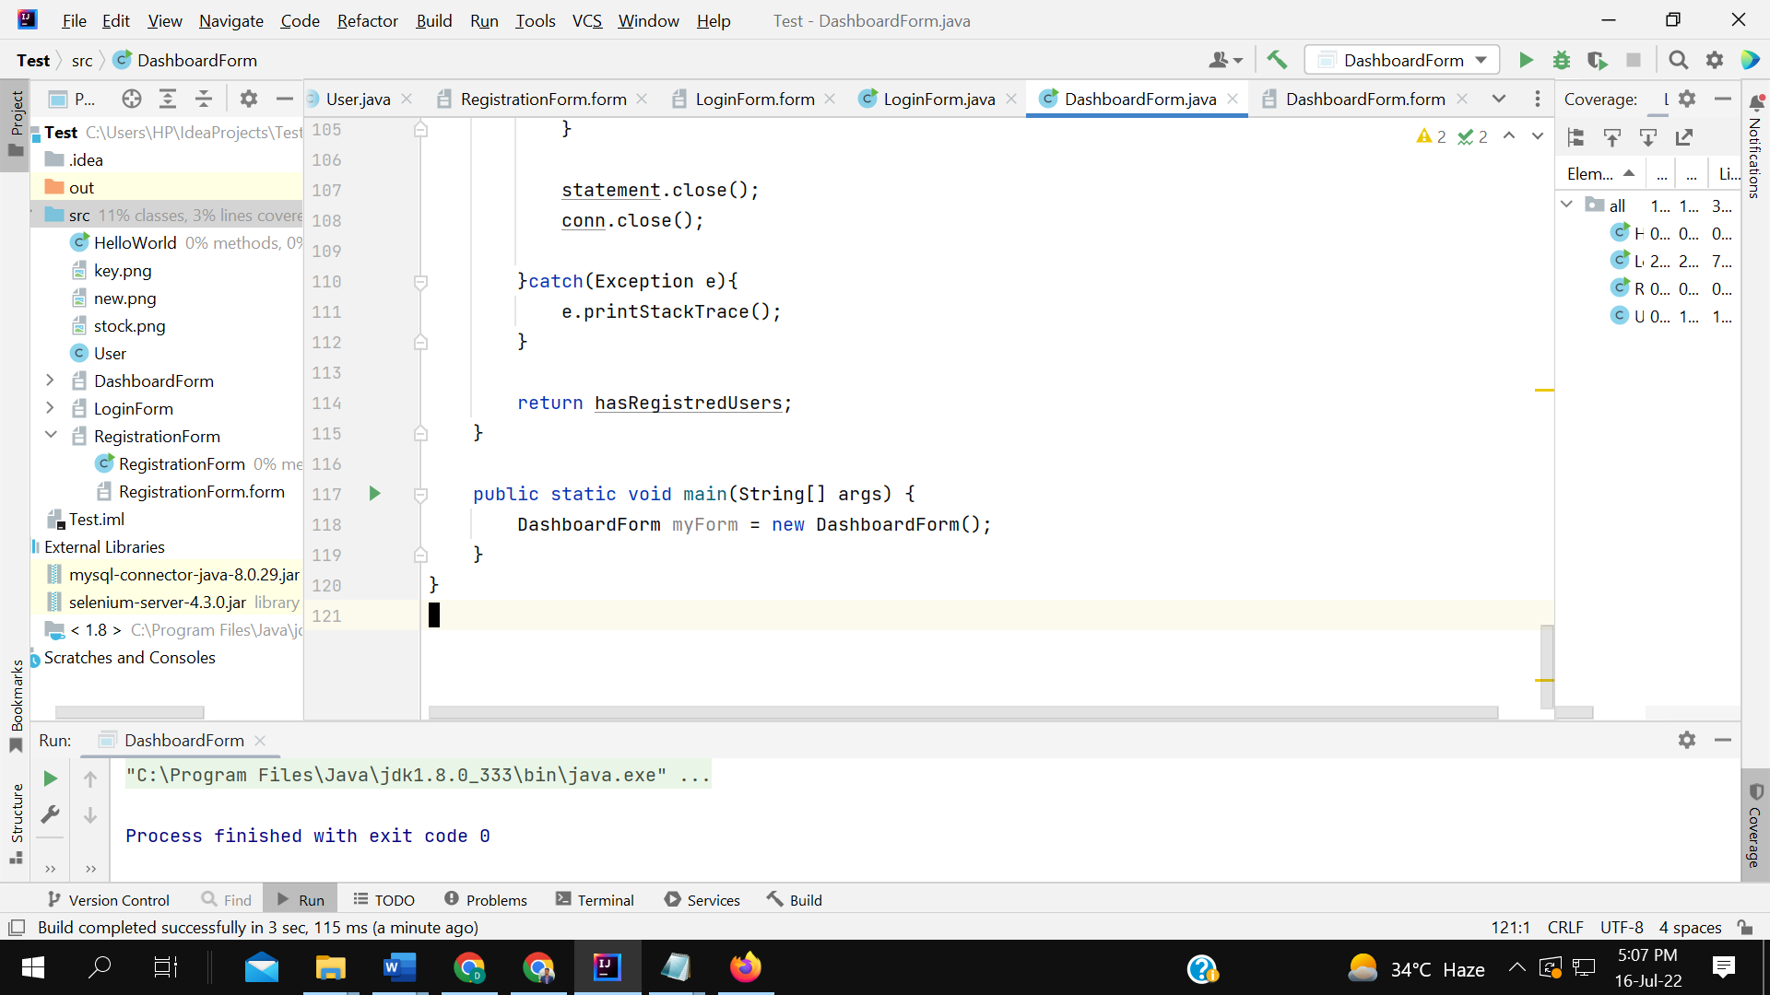

**REDIRECTED TO THE DASHBOARD**

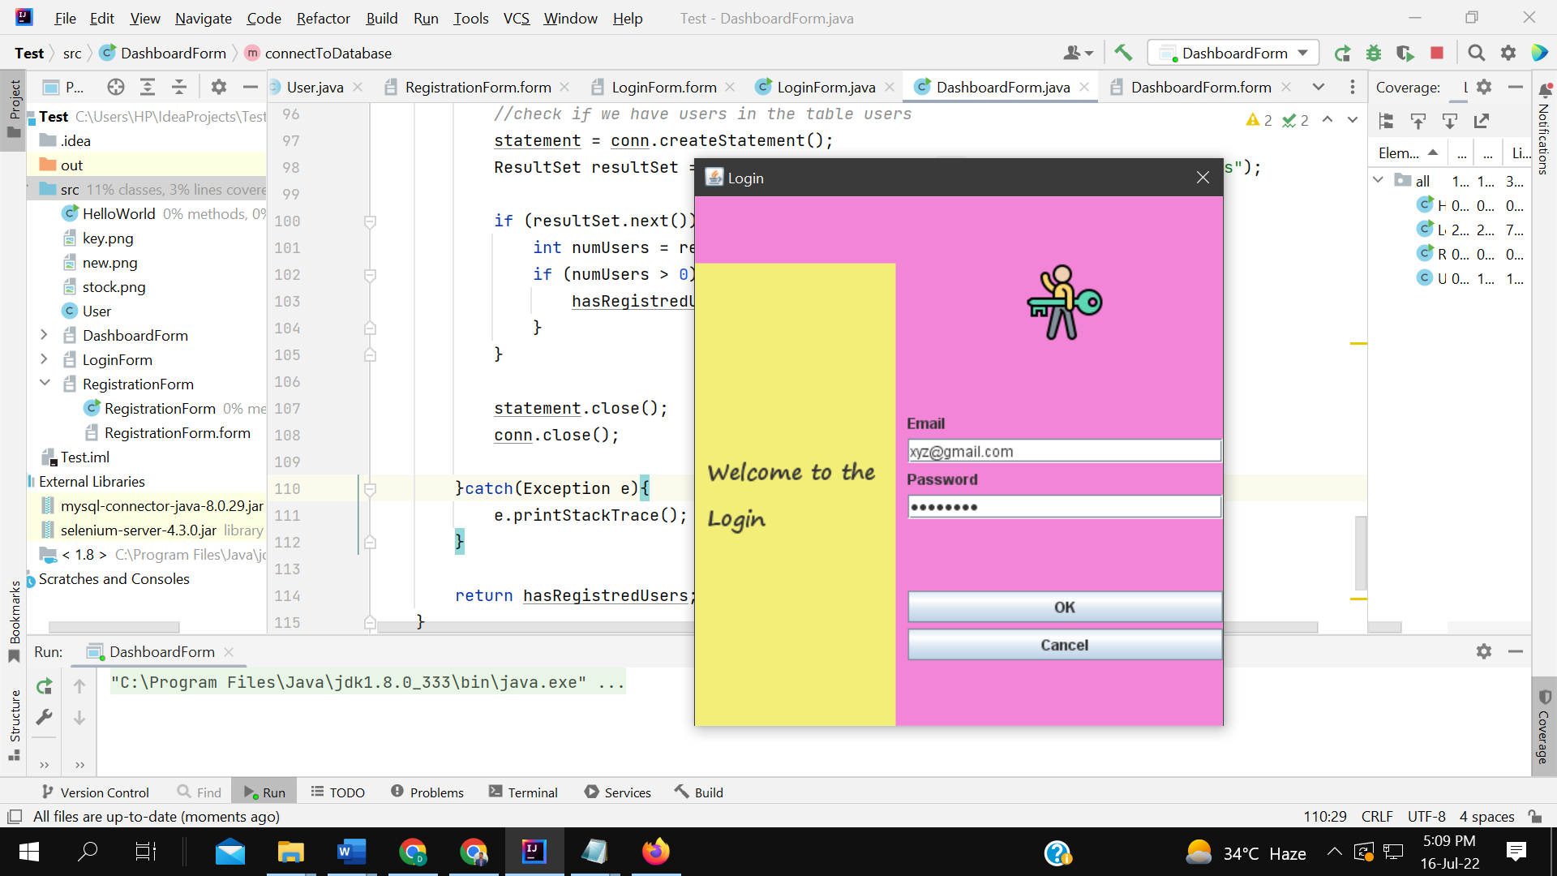

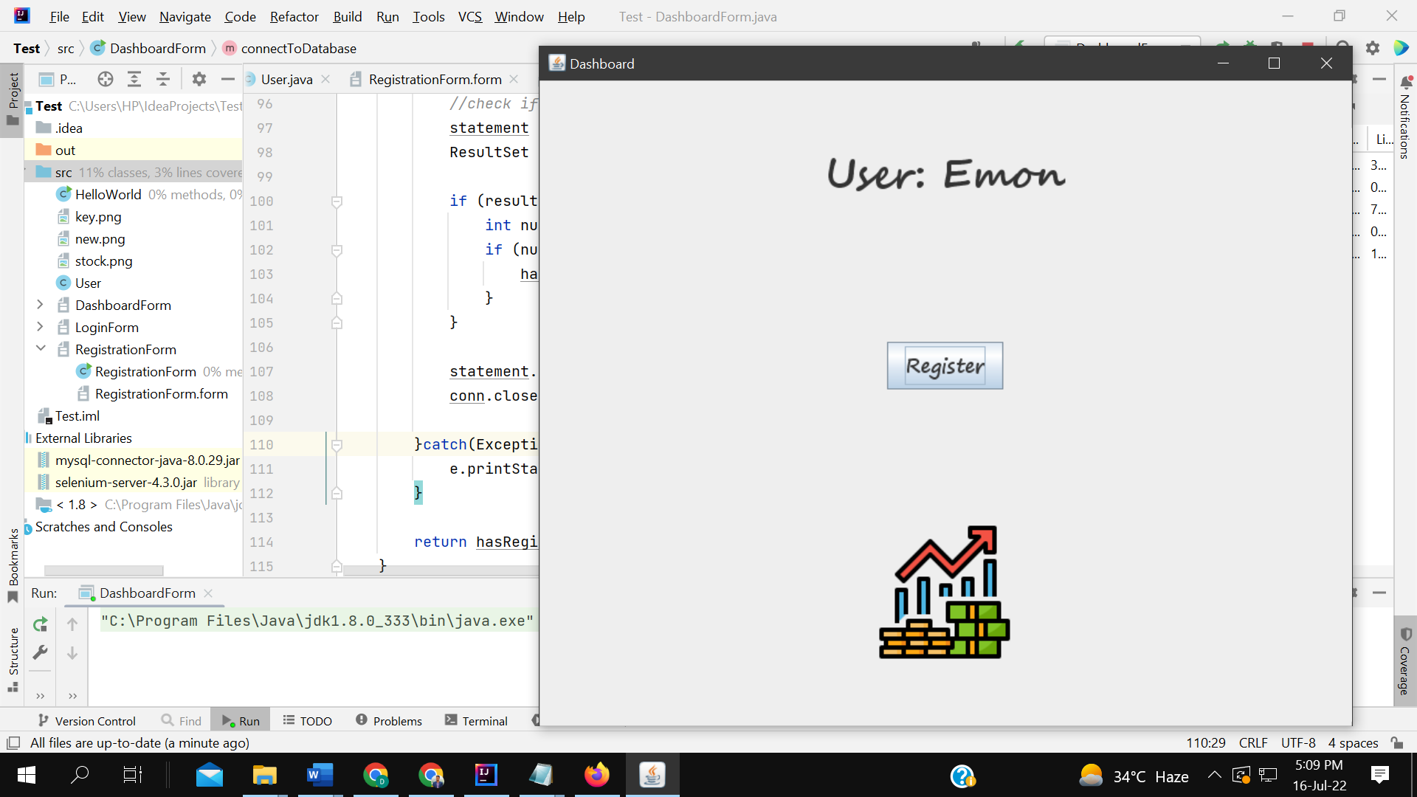

TEST RESULT: SUCCESSFUL

**FOR NEW REGISTRATION:**

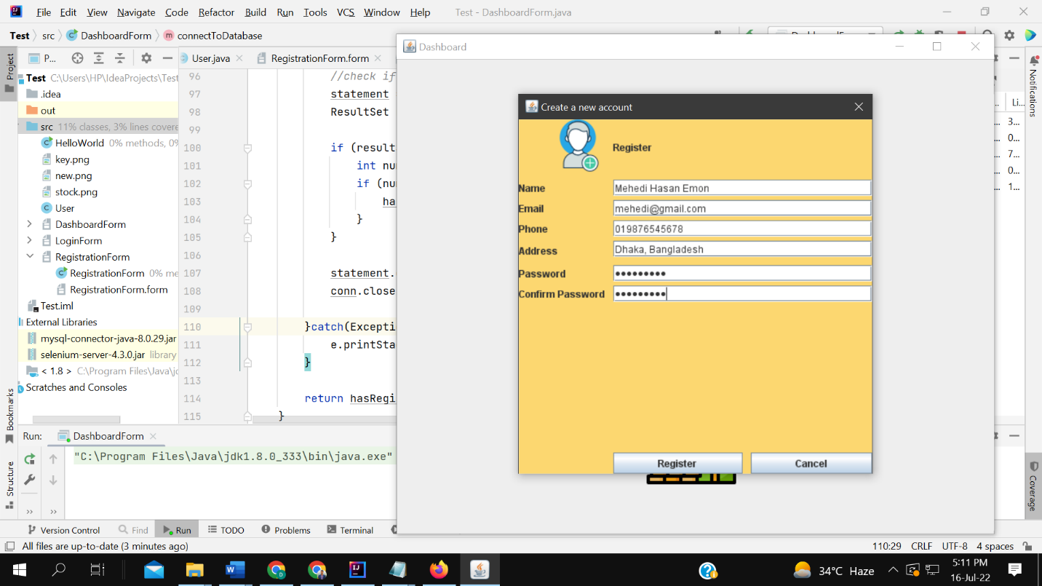

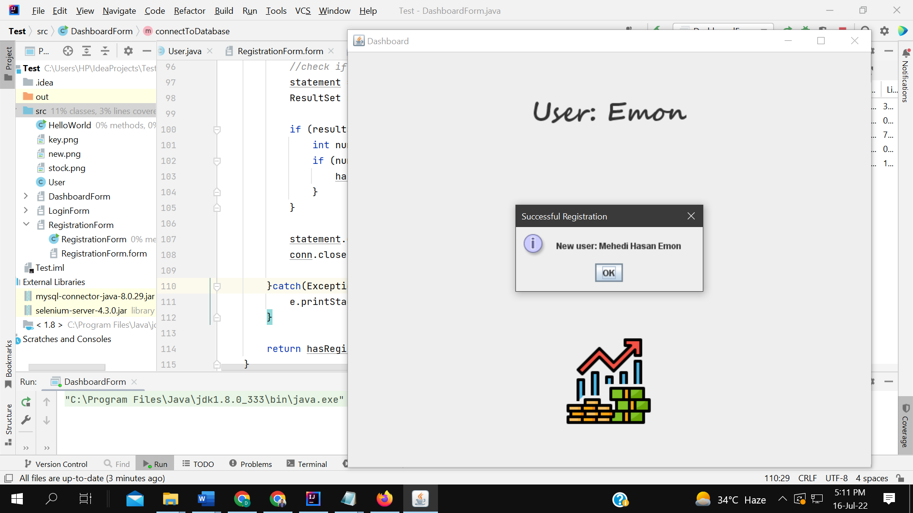

DATABASE

